SUBMITTED BY : KANUPRIYA MITTAL

cREDIT RISK ANALYSIS

**Content:**

1. Introduction
2. Understanding the Basic Data Structure
3. Exploratory Data Analysis
4. Data Cleaning and Preprocessing
5. Actions/Insights from Exploratory Data Analysis
6. Preparing data for Model Building
7. Model Building and Interpretation
8. Comparing the Performance Metrics
9. Interpretation of the Best Model
10. Insights and Recommendations

**1.INTRODUCTION**

**DEFINTION OF PROBLEM STATEMENT**

A Bank is a financial institution that lends money to businesses and people. It is through the interests on the loans given that a financial institution derives its key revenue from. With this money lending, comes a grave risk of defaults on credit. The borrowers might not give back with interest, the amount they borrowed. The risk is colossal and has the potential to cease the existence of a bank too.

**The world isn’t an ideal place. You don’t always get what you give unless you apply analytics to it!**

Hence, it is extremely necessary that a financial institution can gauge the risk beforehand and minimize it. The banks are now scrutinizing the loan applications to identify the potential of risk that each borrower poses.

This contemplation is done by predictive modelling techniques and the better the model accuracy, the lower is the Credit Risk. By employing the model, the bank can take the steps necessary to maintain the stability of its credit situation. The credit risk has to be reduced to the minimum for a bank to keep its functioning intact.

**NEED OF THE STUDY**

The practice of borrowing money from Financial Institutions has increased many folds now thus, creating a potential for more Revenue as well as more Credit Risk. Every day many people borrow for various purposes. There are a lot of cases where borrowers don’t pay the bulk portion of their loans and this incurs huge financial losses for a bank. These losses can even collapse a bank if not handled well in time.

To prevent themselves from getting dissolved, the banks have to assess the potential credit risk involved with every loan that they give. This risk can be assessed by the application of machine learning algorithms on the dataset provided by a financial institution and achieving a model that predicts with the highest accuracy whether a borrower will default or not. A model with the best accuracy on the banks data of loan records has to maneuvered to provide the best of the prediction ability.

The banks can use this model to decide on the loan applications and choose the borrowers that pose the least risk of default. They can cancel the applications of those who are at high risk and reduce their chances of losses. The prediction of defaulters will give the banks an insight and they can choose how to act upon it. Thus, banks need to play safe by playing with analytics.

**Loan status:** To estimate this with perfection is our goal. this is the objective of our study. Banks depend on this for their revenues.

There are 2 outcomes to any loan:

The borrower will clear the loan

The borrower will default on the loan

We are dealing with a **classification** scenario.

**UNDERSTANDING THE BUSSINESS/ SOCIAL OPPORTUNITIES**

Business Impact: There is a mammoth competition between the various financial institution to take the top place in the market. The banks which are strong in the market are the attractions for a customer. The customer has faith in the name of the bank. So, this will bring more customers to buy financial services from these banks and will make a good impact on the revenue the bank creates. With more number of customers applying for loans, the handling of credit risk becomes immensely crucial. The banks have to use the model for the prediction of Default risk so that they don’t experience loss of money and customers. A right model can make the Financial Institution flourish. The model should be able to handle the dynamically generated data with the best of the efficiency.

Social Impact: Credit risks have an impact of the socio-economic grounds too. A bank can collapse due to mishandled credit risk and it affect the economic development of a country. There is a competition amongst the banks to be more lucrative for the customers. In order to attract more customers, the banks are continually improving their approaches to loan and banking. It is important the banks have clear and transparent policies for loan and also for risk management. this will induce a trust within the customers. Customers expect the financial institutions to have strong policies that can safeguard their interests and protect them. The ambiguous nature of the terms and conditions should be simplified in order to make it easier for people to understand that what a bank is offering and how exactly.

**2. UNDERSTANDING THE BASIC DATA STRUCTURE**

**THE COLLECTION OF DATA BASED ON VARIOUS METRICS:**

**In terms of Time**: There are records when the Earliest Credit Lines of all the Customers. borrowers. The current loan details are very well recorded with all the important aspects pertaining to the transactions. The last payment dates are also captured along with the last credit pulled date for all the borrowers. We can see the loan data from the 2008 – 2016.

**In terms of Frequency:** we can observe that the data gets generated by the staff whenever there is any transaction related to a borrower. The current loan details are recorded **monthly** whenever a credit is pulled or a payment is made by the borrower.

**In terms of Methodology:** Almost all the data in banks is generated by the transactions that a customer does. In this data, we are provided with all the Loan Based Transactions and the financial aspects of the borrower

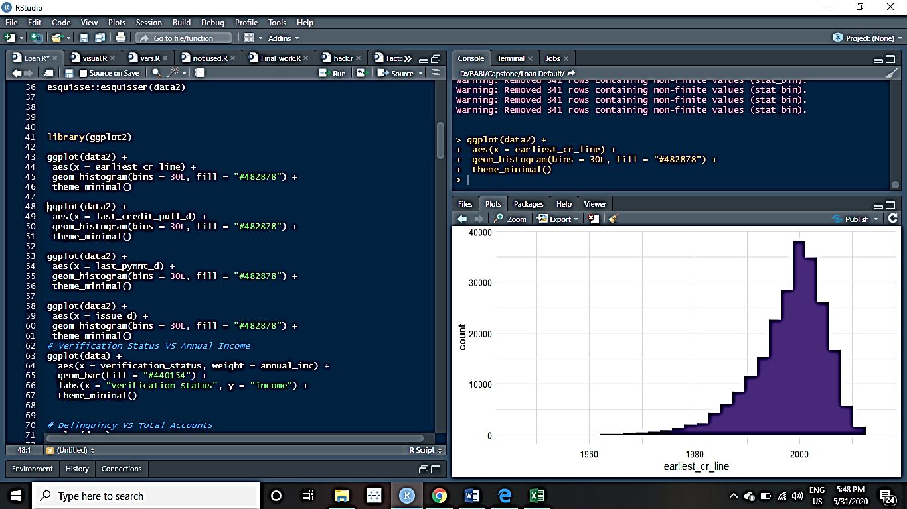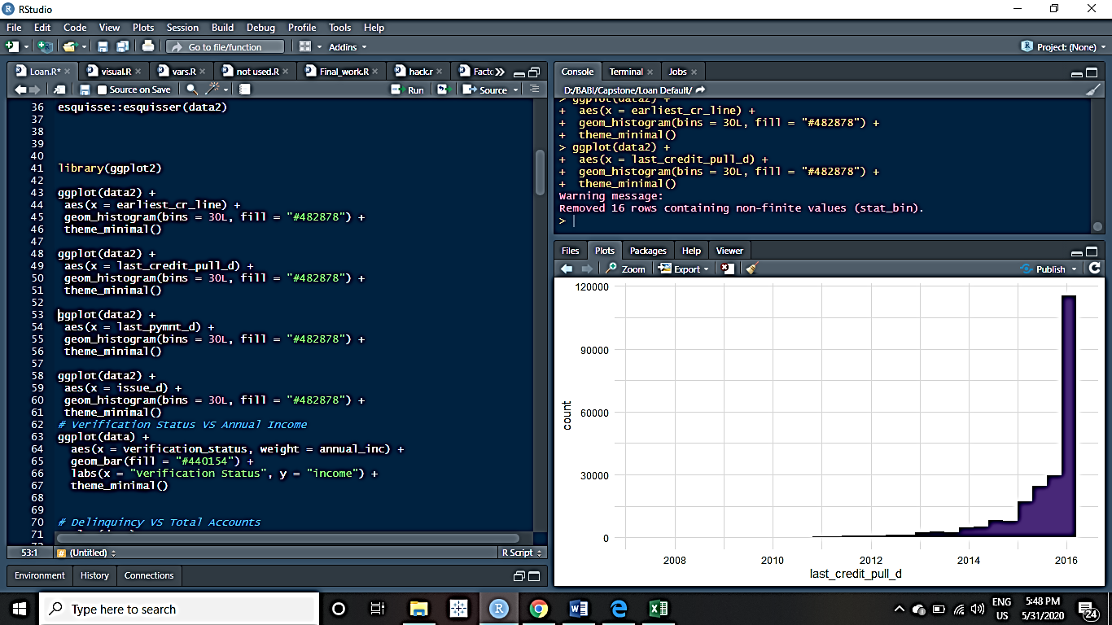

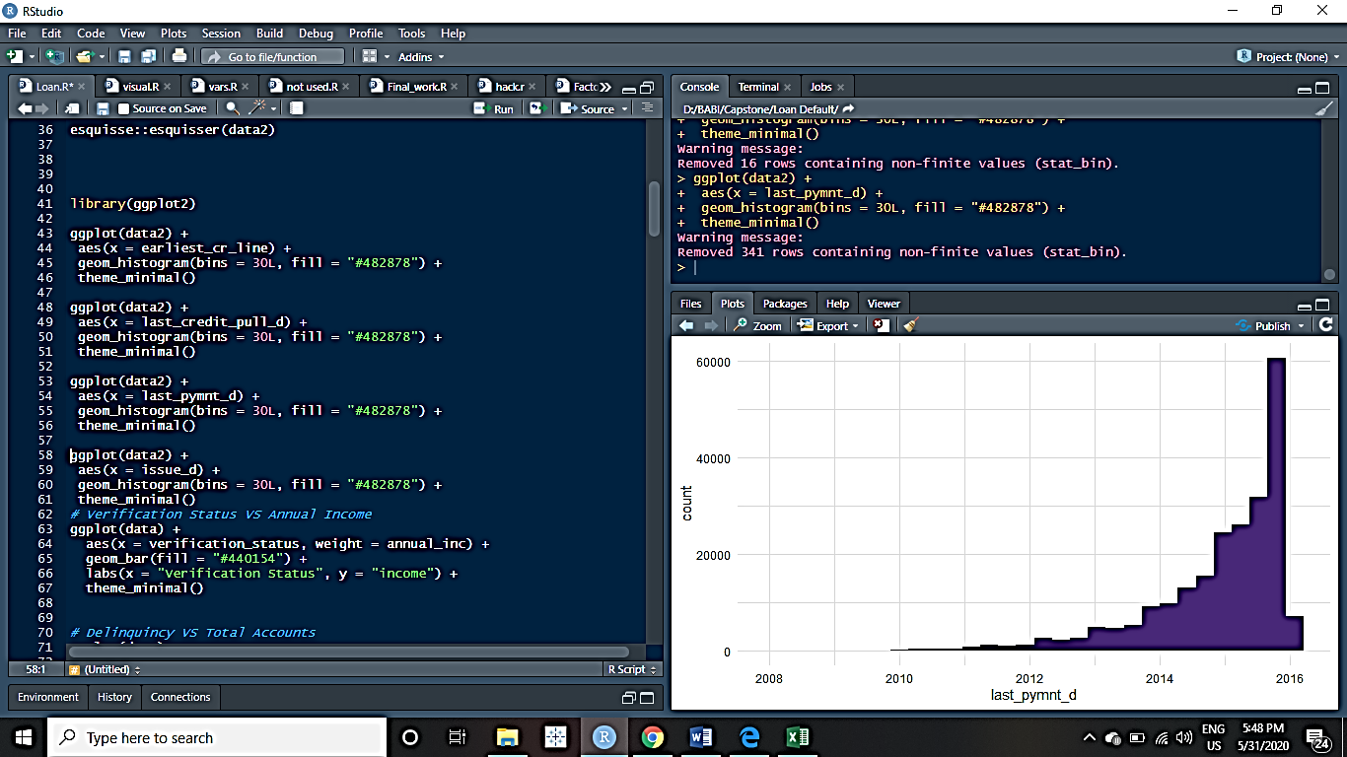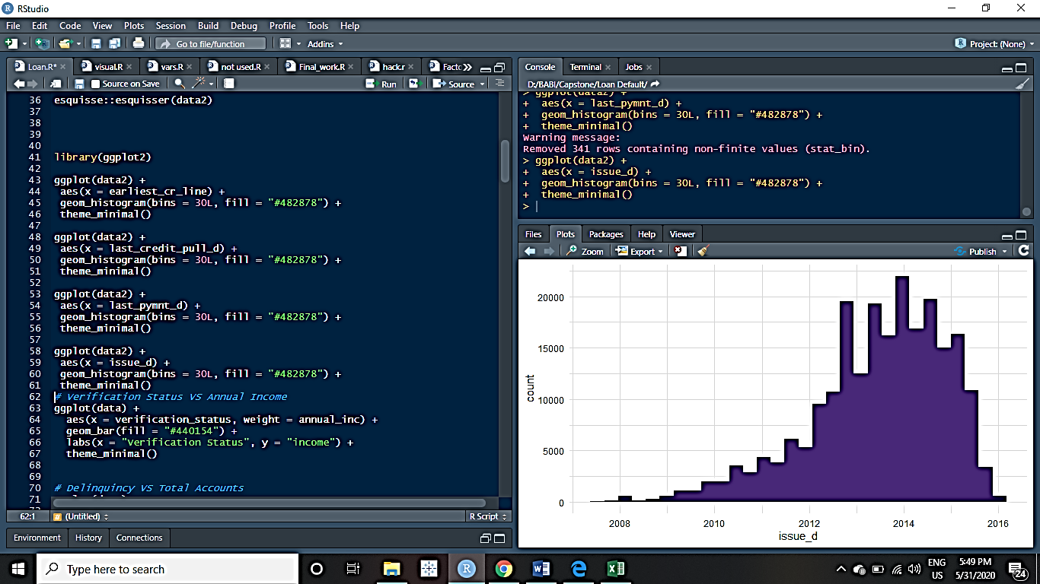

**INSPECTION OF THE DATA**

Let’s talk about the attributes and the number of records we have with us.

There are 41 unique variables and 226786 records in total.

Character variables = 11

Numerical = 25

Date/Time based variables = 5

Structure of the Dataset: There are 3 types of variables in our data. As we shall move ahead, we’ll transform and remove some variables. The dataset contains variables having values on very different scales.

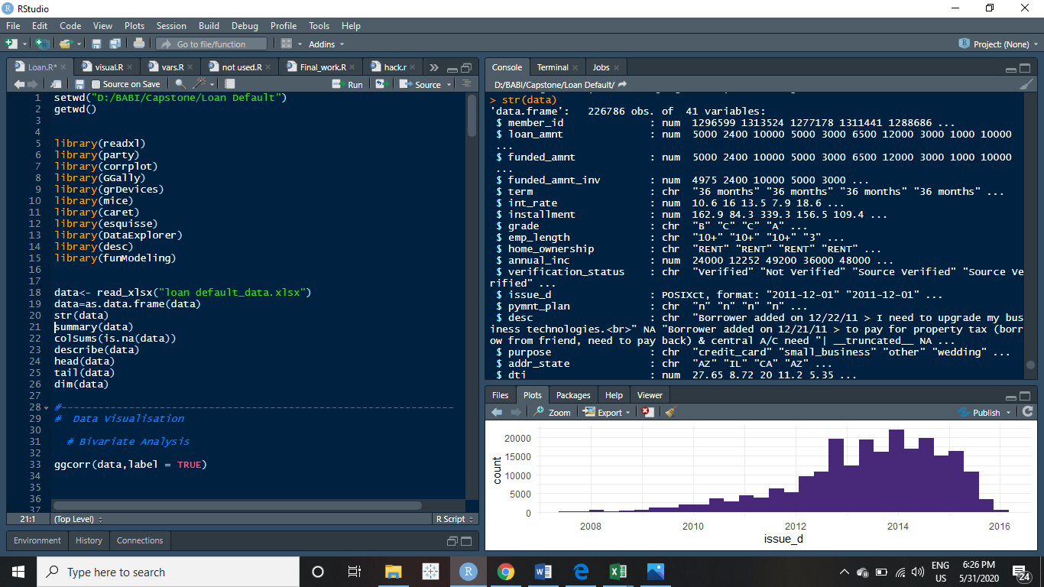

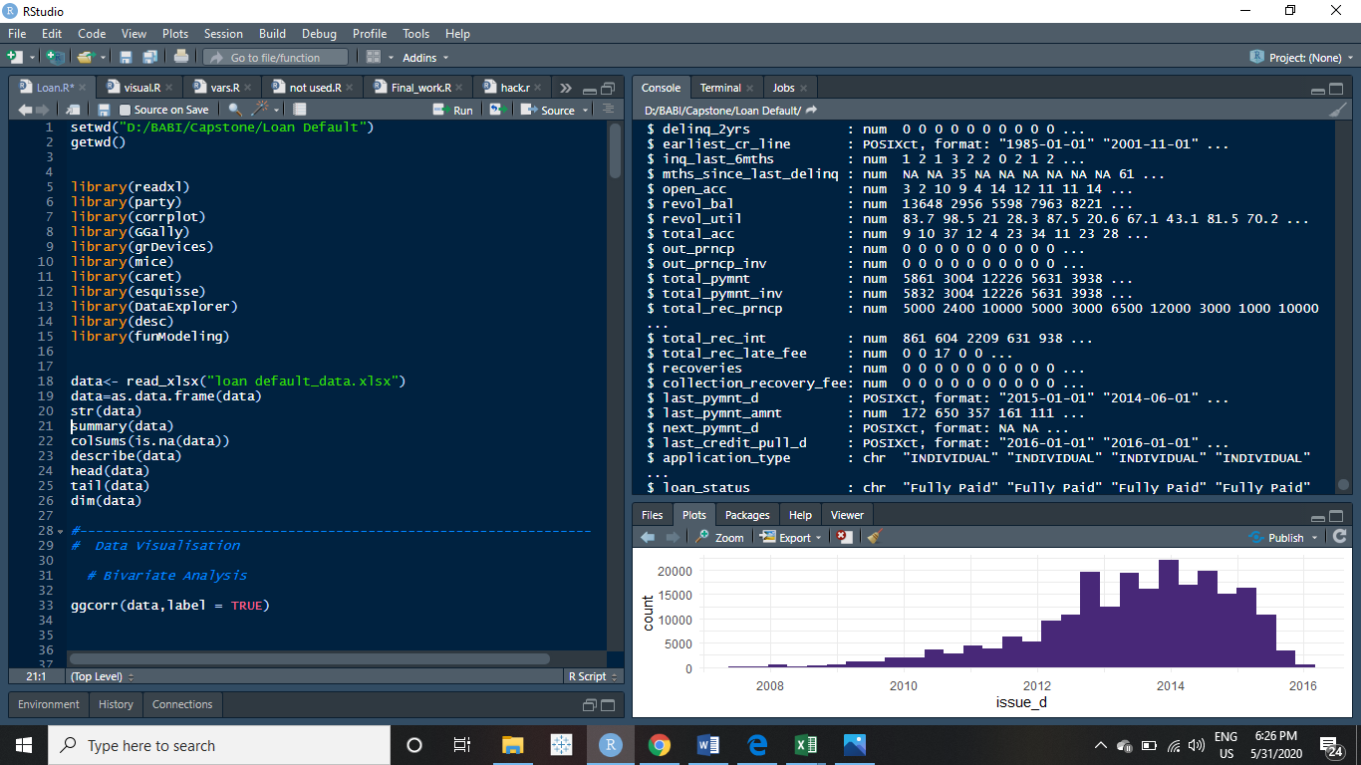

print(profiling_num(data),digits=2)

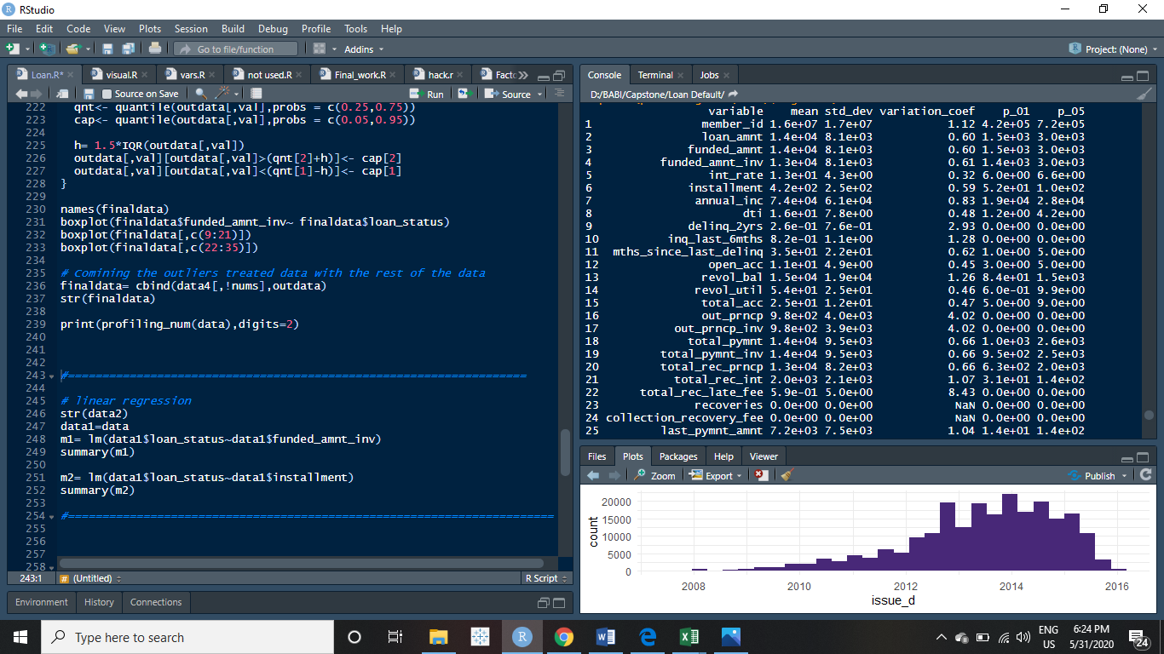

This depicts the mean and the standard deviations in the values of all the numerical variables.

We see a standard deviation of as high as 8.1e+03 ( loan_amount) to as low as 0.0e+00 (recoveries, etc)

The data is extremely unbalanced.

**FIGURING OUT OF THE ATTRIBUTES**

|  |  |
| --- | --- |
| **Fields** | **Description** |
| member_id | A unique Id for the borrower member. |
| loan_amnt | The listed amount of the loan applied for by the borrower. If at some point in time, the credit department reduces the loan amount, then it will be reflected in this value. |
| funded_amnt | The total amount committed to that loan at that point in time. |
| funded_amnt_inv | The total amount committed by investors for that loan at that point in time. |
| term | The number of payments on the loan. Values are in months and can be either 36 or 60. |
| int_rate | Interest Rate on the loan |
| installment | The monthly payment owed by the borrower if the loan originates. |
| grade | Assigned loan grade |
| emp_length | Employment length in years. Possible values are between 0 and 10 where 0 means less than one year and 10 means ten or more years. |
| home_ownership | The home ownership status provided by the borrower during registration. Our values are: RENT, OWN, MORTGAGE, OTHER. |
| annual_inc | The self-reported annual income provided by the borrower during registration. |
| verification_status | Status of the verification done |
| issue_d | The month which the loan was funded |
| pymnt_plan | Indicates if a payment plan has been put in place for the loan |
| desc | Loan description provided by the borrower |
| purpose | A category provided by the borrower for the loan request. |
| addr_state | The state provided by the borrower in the loan application |
| dti | A ratio calculated using the borrower’s total monthly debt payments on the total debt obligations, excluding mortgage and the requested LC loan, divided by the borrower’s self-reported monthly income. |
| delinq_2yrs | The number of 30+ days past-due incidences of delinquency in the borrower's credit file for the past 2 years |
| earliest_cr_line | The month the borrower's earliest reported credit line was opened |
| inq_last_6mths | The number of inquiries in past 6 months (excluding auto and mortgage inquiries) |
| mths_since_last_delinq | The number of months since the borrower's last delinquency. |
| open_acc | The number of open credit lines in the borrower's credit file. |
| revol_bal | Total credit revolving balance |
| revol_util | Revolving line utilization rate, or the amount of credit the borrower is using relative to all available revolving credit. |
| total_acc | The total number of credit lines currently in the borrower's credit file |
| out_prncp | Remaining outstanding principal for total amount funded |
| out_prncp_inv | Remaining outstanding principal for portion of total amount funded by investors |
| total_pymnt | Payments received to date for total amount funded |
| total_pymnt_inv | Payments received to date for portion of total amount funded by investors |
| total_rec_prncp | Principal received to date |
| total_rec_int | Interest received to date |
| total_rec_late_fee | Late fees received to date |
| recoveries | post charge off gross recovery |
| collection_recovery_fee | post charge off collection fee |
| last_pymnt_d | Last month payment was received |
| last_pymnt_amnt | Last total payment amount received |
| next_pymnt_d | Next scheduled payment date |
| last_credit_pull_d | The most recent month pulled credit for this loan |
| application_type | Indicates whether the loan is an individual application or a joint application with two co-borrowers |
| loan_status | Current status of the loan |

**3. EXPLORATORY DATA ANALYSIS**

It is a culmination of Descriptive and Exploratory Data Analysis. It is done to understand the basic data structure as well as to visualize the dataset before performing any modelling. It checks for the relationship between the variables through the use of graphs. And also gives the summary and the class of each variable.

|  |  |
| --- | --- |
| **Loan Status** | **Sum of funded amount** |
| Default | Rs.29,90,40,575 |
| Fully Paid | Rs.2,76,41,40,500 |
| Grand Total | Rs.3,06,31,81,075 |

UNIVARIATE ANALYSIS

Done for both categorical and continuous variables.

* **Categorical variable’s Distribution Analysis by Barplots**

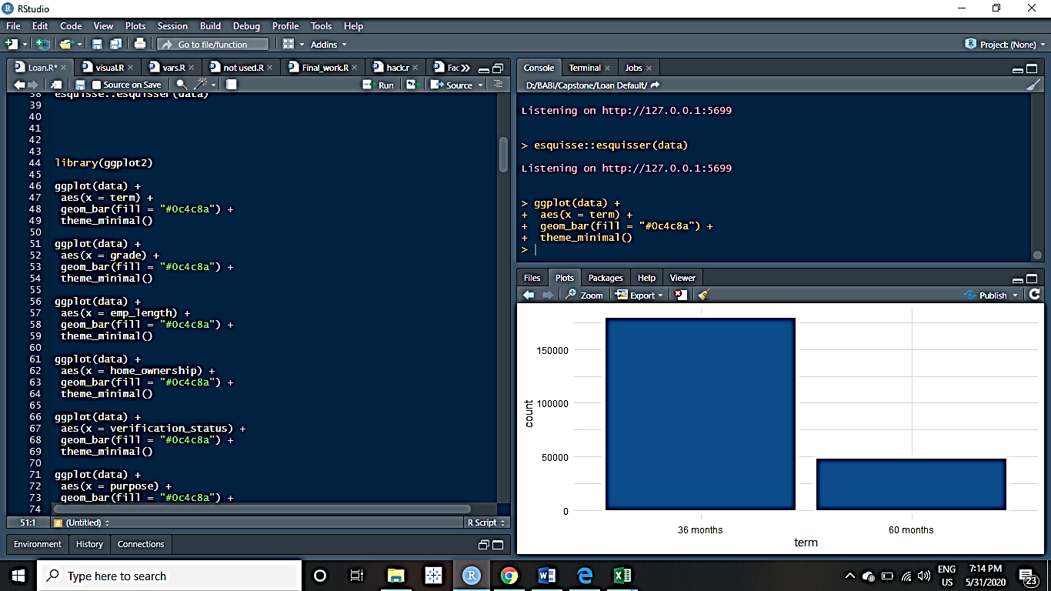 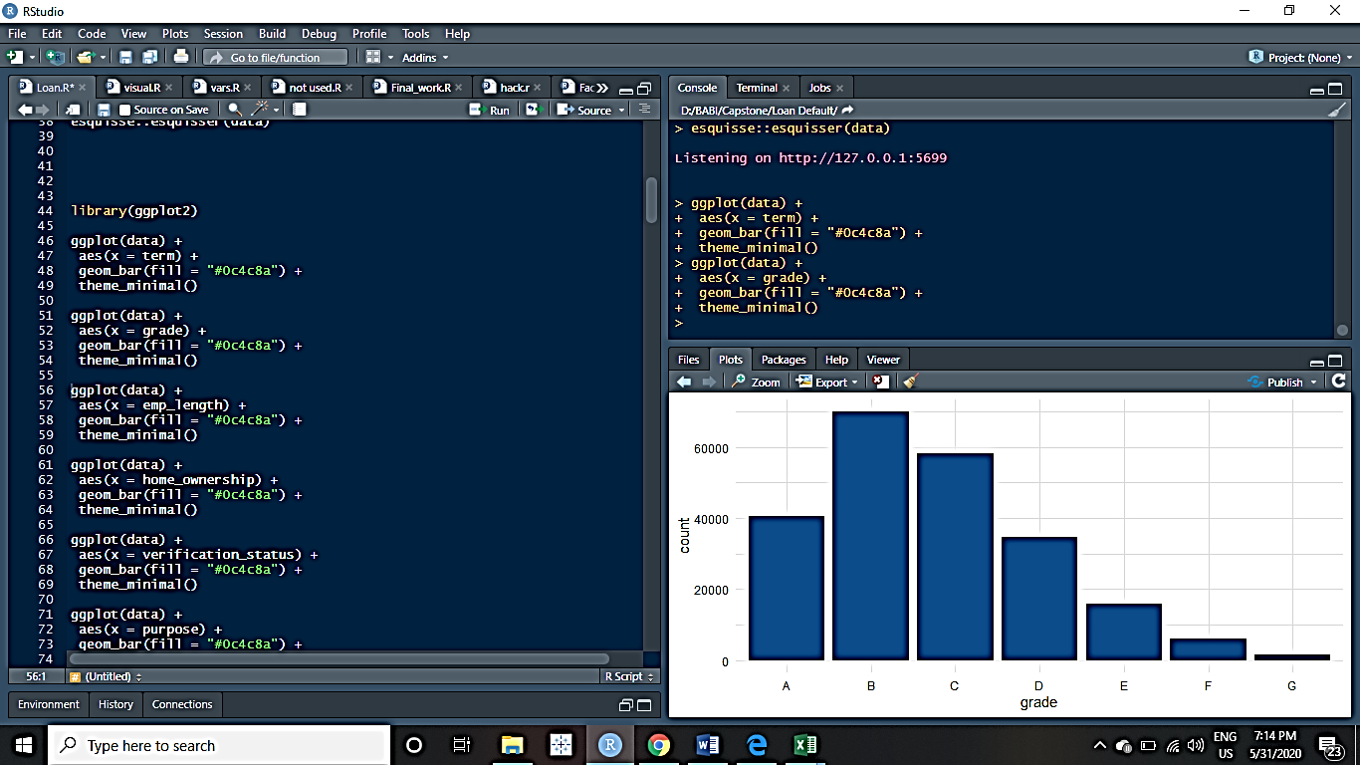

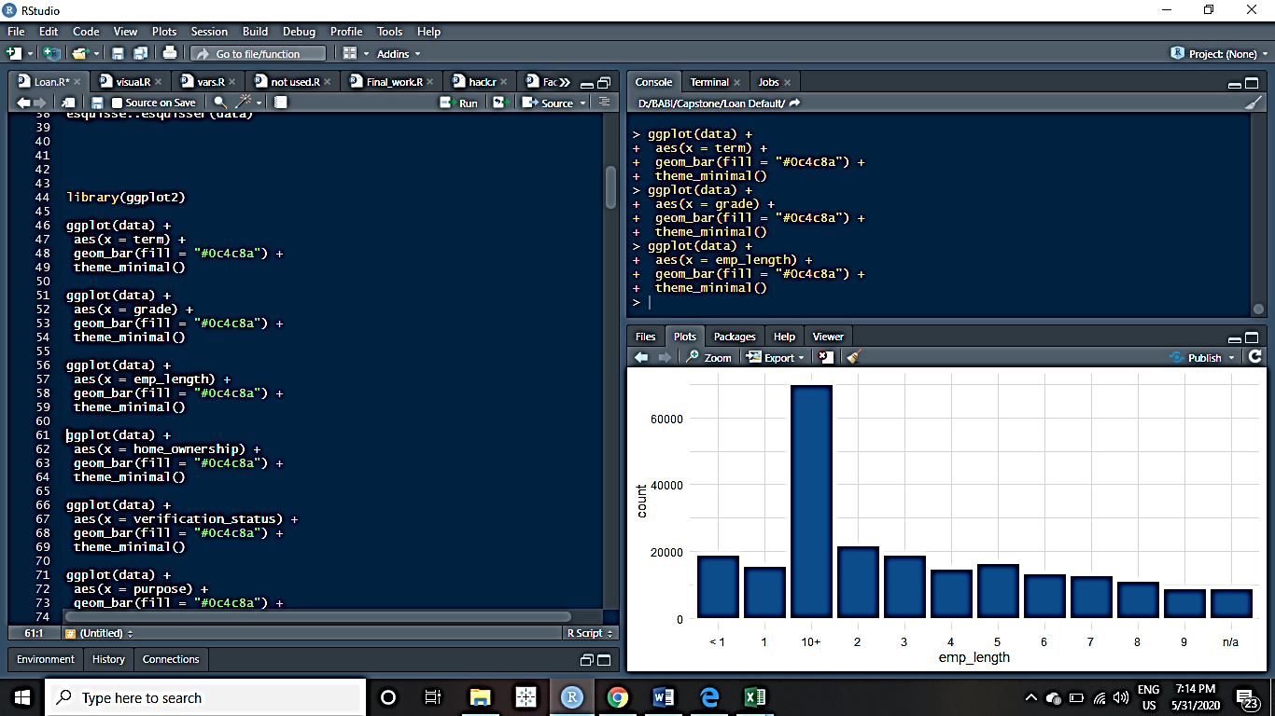 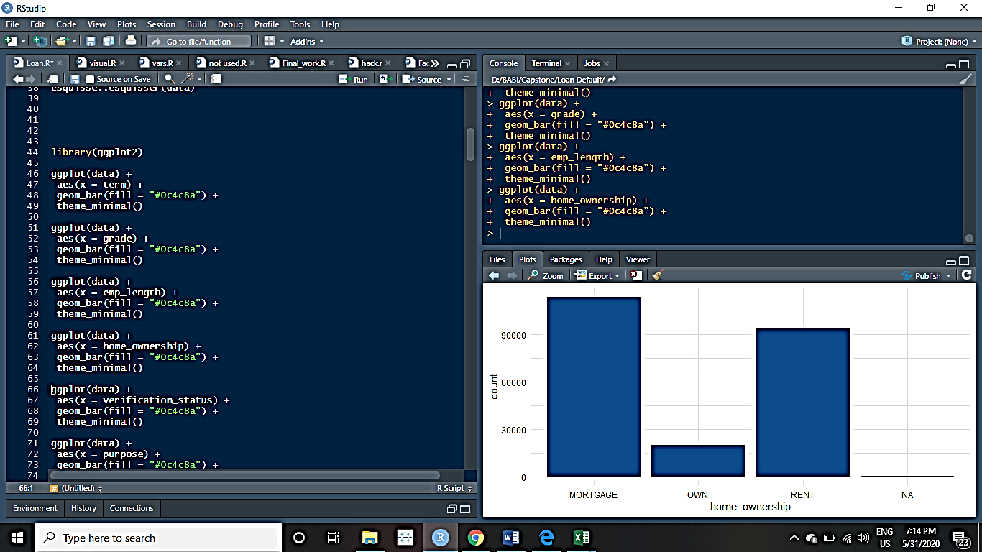

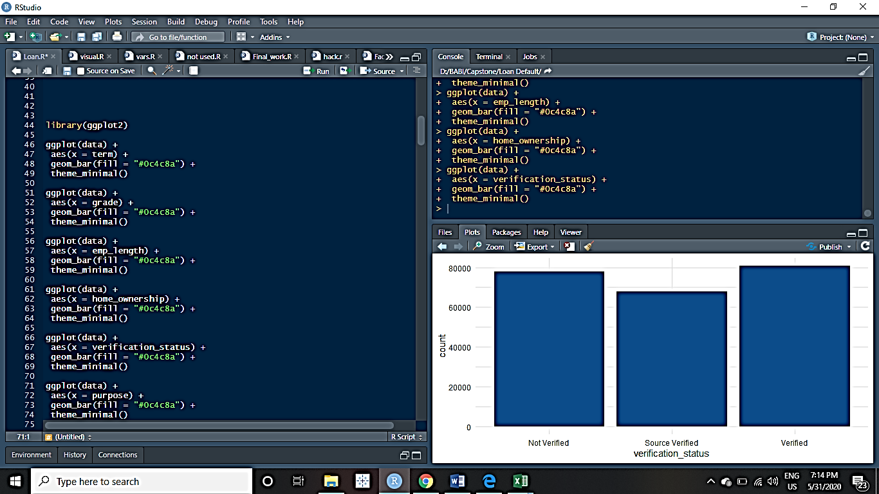 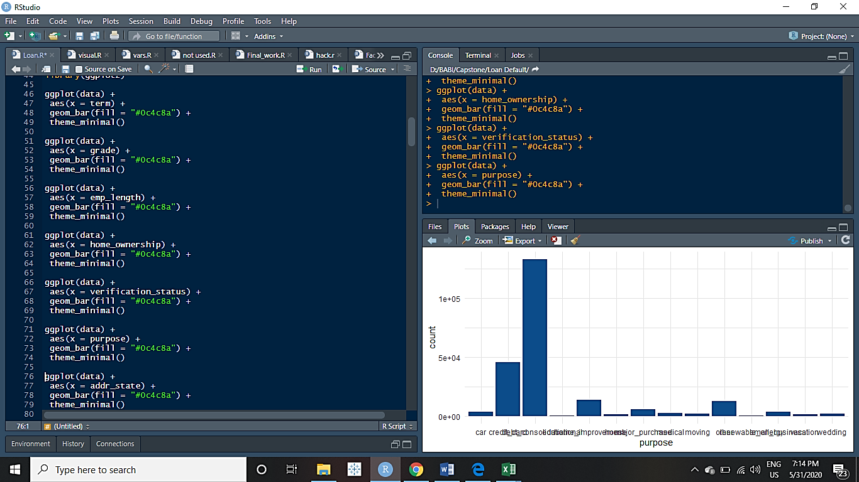

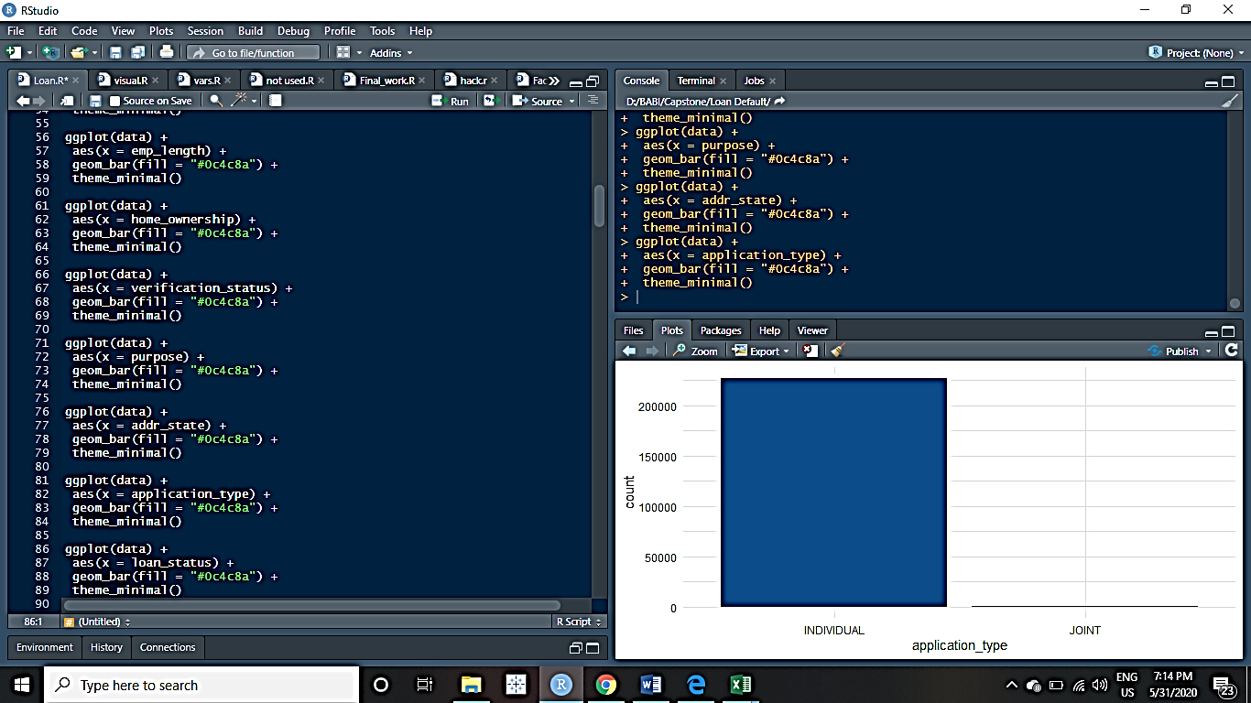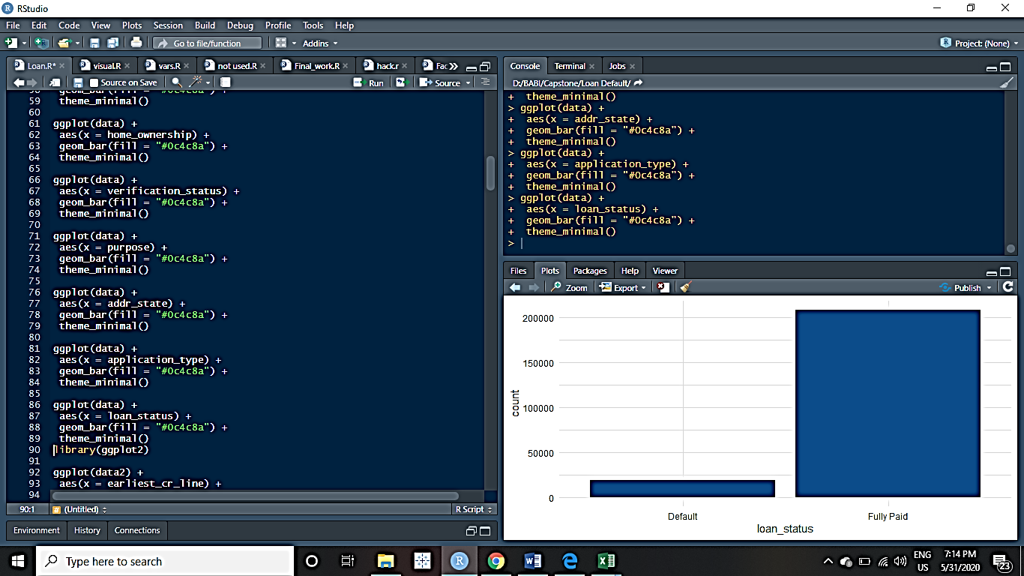

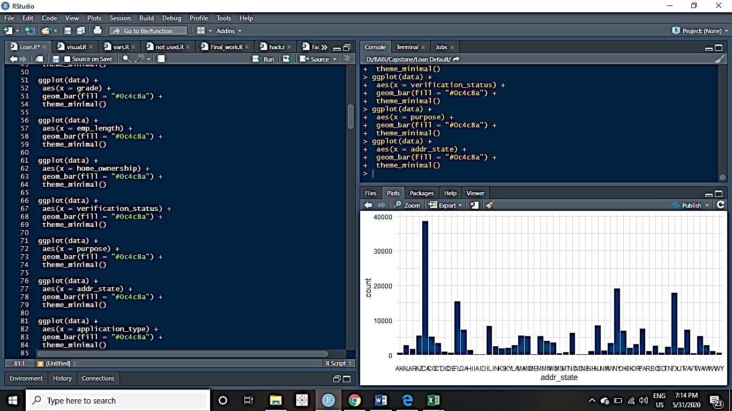

* **Continuous variable’s Distribution Analysis by Histogram**

A **histogram** consists of parallel vertical bars that graphically shows the frequency distribution of a quantitative variable.

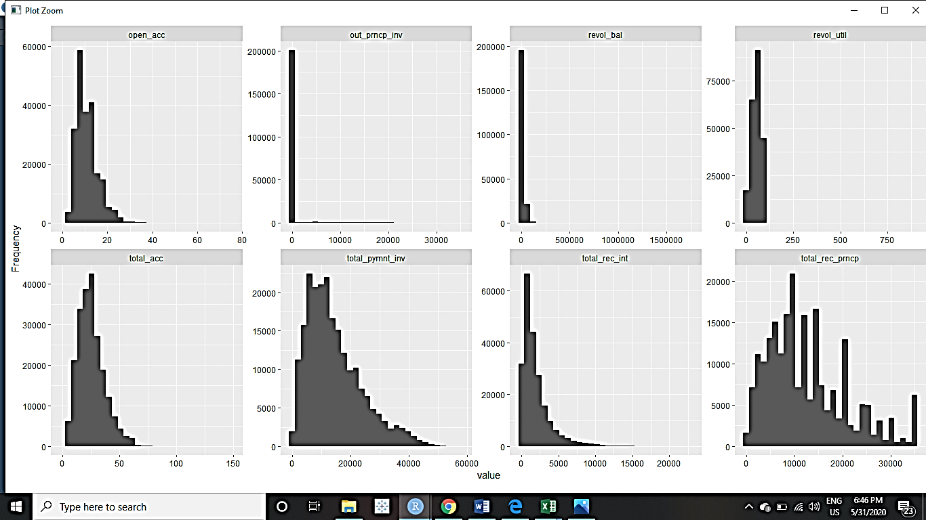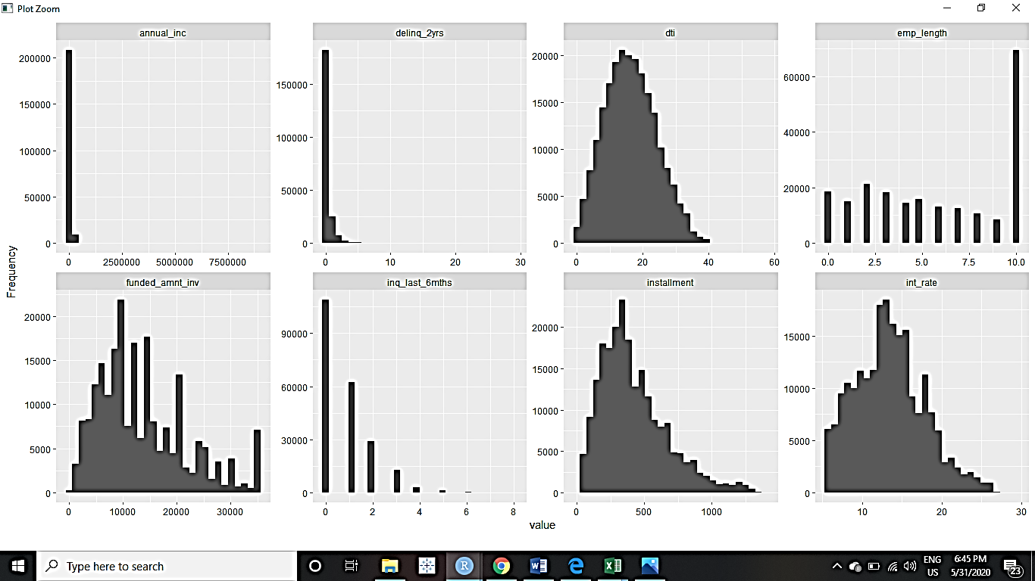

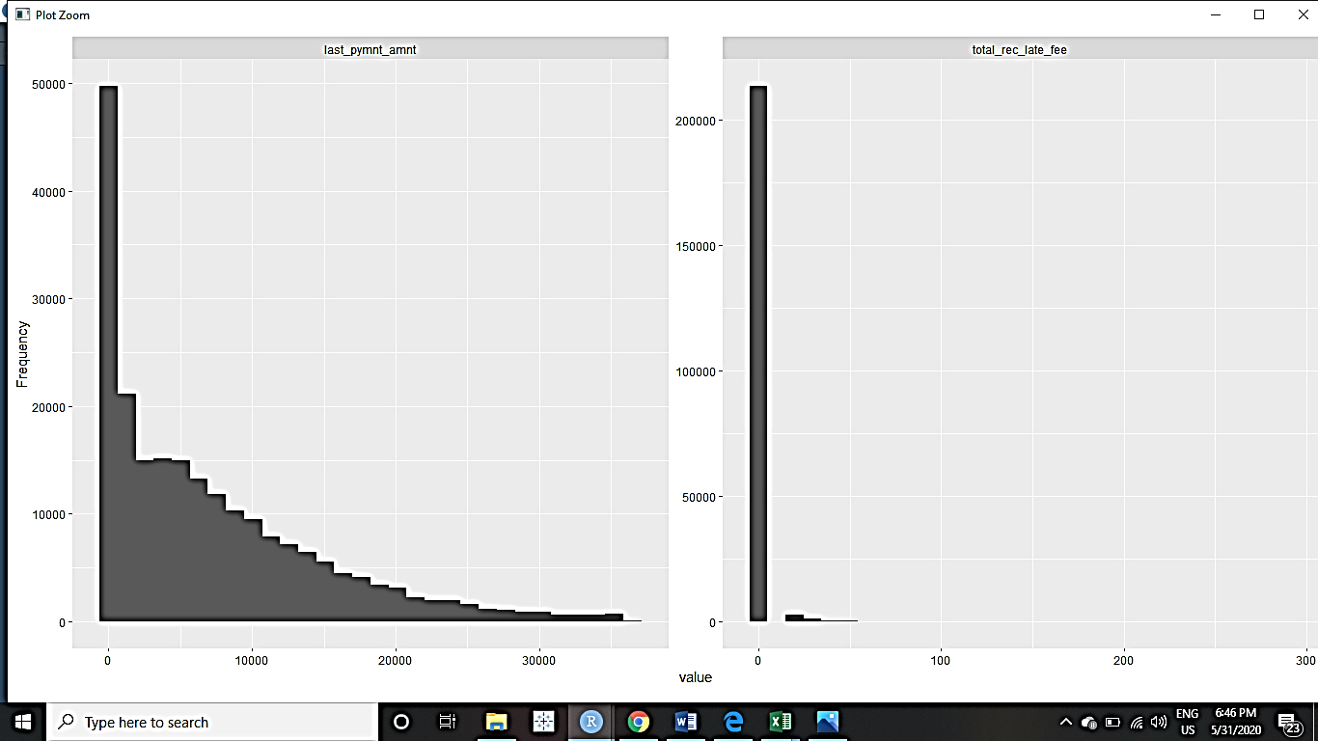

**BIVARIATE ANALYSIS**

These depict the relationship between multiple variables simultaneously. We make bargraphs, scatter plots, boxplots for signifying the relationship between variables.

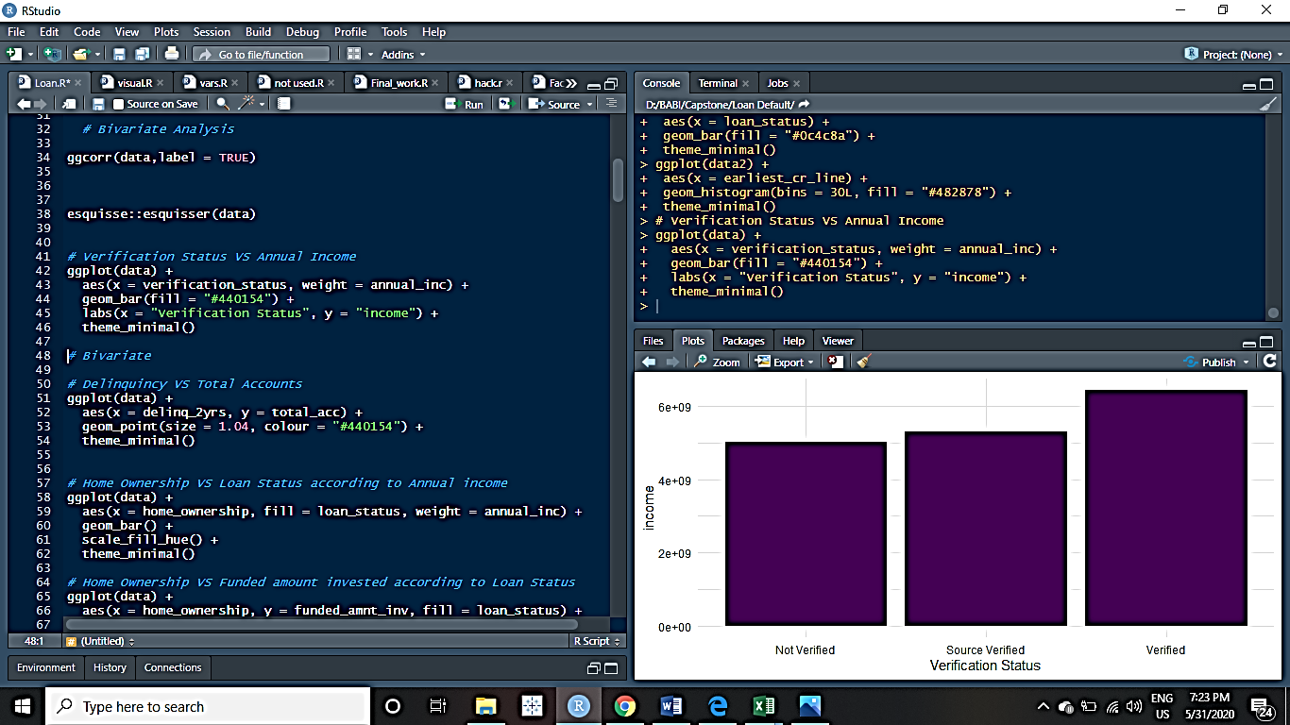 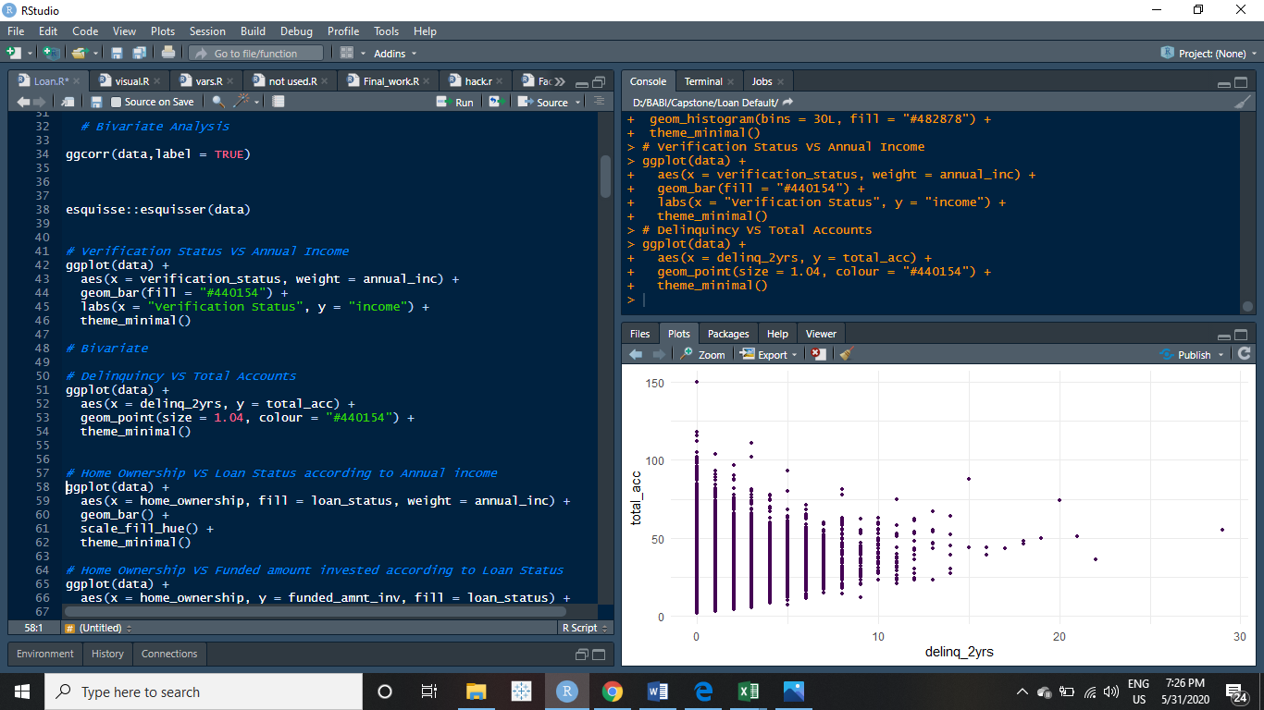

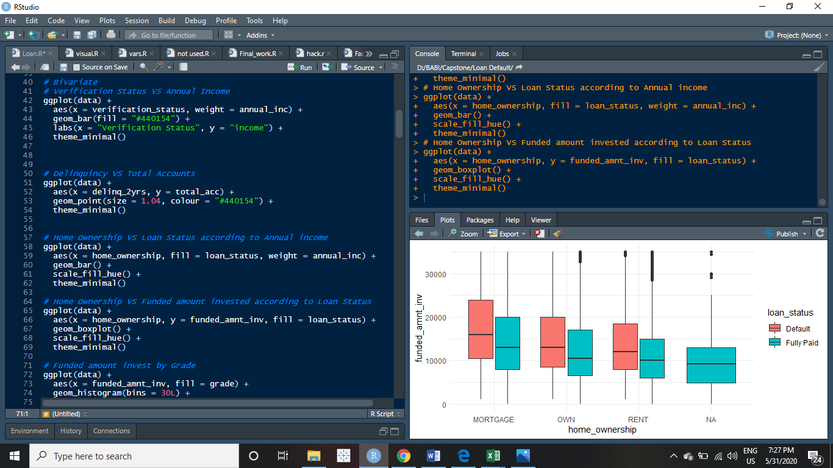

**MULTIVARIATE ANALYSIS**

These depict the relationship between multiple variables simultaneously. We make bargraphs, scatter plots, boxplots for signifying the relationship between variables.

1.We observe that the majority of loans were taken for the purpose of **Debt Consolidation**, and in turn majority of defaults also happened for the same.

2. We can see a high chance of default where the number of **delinquencies** are more except for some exceptions. The borrowers who never delayed payments pose the least risk.

3. We can understand from this graph that more **verifications** were done and the number of non-verified borrowers were reduced from 100% to 25% over the period of 2007-2015

4. We observe a bad trend here. The defaults are increasing over the years. And in 2015, more than 25% of the borrowers defaulted on their loans.

5.Majority of our Borrowers/ the cream customers for the bank reside in **CA** followed by **NY -> TX -> FL**.

6.The state of **NE** followed by **MS -> TN -> IN** are the states with the most high occurrences of Defaults. Special scrutiny should be done before approving the loans for the customers of these states.

**CORRELATION MATRIX**

Correlation Matrix is created so as to know the degree of correlation between all the independent variables. It ranges from -1 to +1. We try to reduce the multicollinearity as much as possible because shadows the effect of one variable over the target variable and produce non-real predictions.

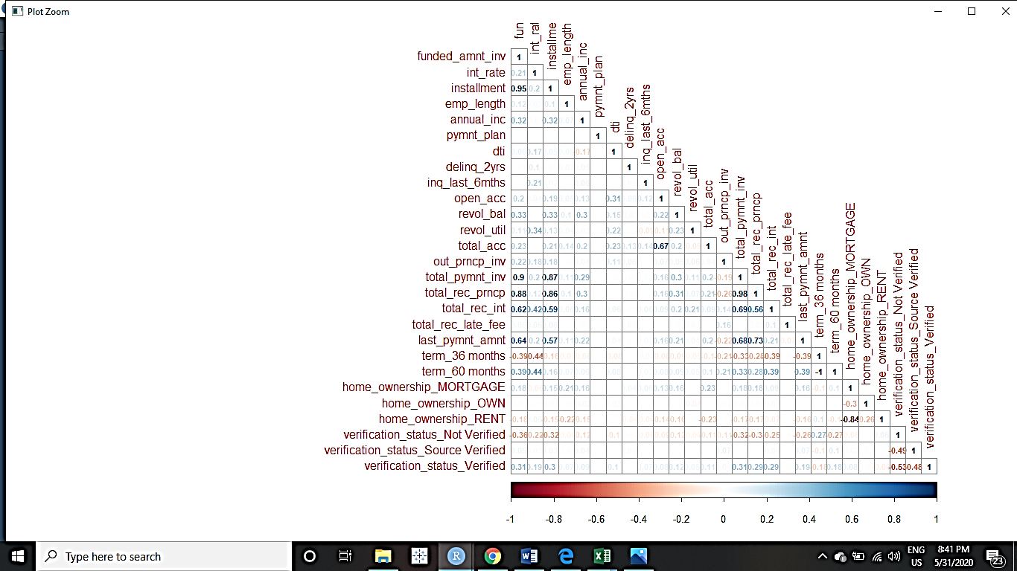

We infer that there is a very normal relation between the variables. No significant occurrences of multicollinearity can be seen.

**4. DATA CLEANING AND PRE-PROCESSING**

We’ll prepare the raw data to make it suitable for building and training Machine Learning Models.

Data Preprocessing is that step in which the data gets transformed, or Encoded, to bring it to such a state that now the machine can easily parse it. In other words, the features of the data can now be easily interpreted by the algorithm.

**REMOVAL OF UNWANTED VARIABLES**

Some unnecessary variables are to be removed.

-> Variables with more than 50% missing values:

1. Description

2. Months since last delinquency

3. Next payment date

-> Variables which have super- collinearity and are almost identical with other variables

1. Loan amount

2. Funded amount

3. out_principal

4. Total payment

-> Variables which have only 1 same value throughout the records

1. Recoveries

2. Collection recovery fee

3. Application Type

4. Total recovered late fee

**VARIABLE TRANSFORMATION**

There are 3 Types of variables in the data set. The machine learning algorithm can handle the numerical variables quite well. so we will make transformations with the categorical ones. Date type variables will be left untransformed.

**Posixct variables :** These variables were converted into number of days.

**Categorical variables:** These variables were transformed in a way that the categories were reduced to a low number and then Dummy Variables were created.

**Target Variable:** This variable is converted into factors of 0 and 1 where, 0-> no default and 1-> default

This numeric data will be scaled so that our algorithm can converge easily and a robust model can be created.

* Combining some of the levels of purpose , as they contribute less

data1$purpose= fct_collapse(data1$purpose, others = c("other","car","educational","house",

"major_purchase","medical","moving",

"renewable_energy","small_business",

"vacation","wedding"))

* One hot-encoding to make Dummy Variables

The different levels of categorical variable are made into independent dummy variables with values of 0 /1.  A **one hot encoding** allows the representation of categorical data to be more expressive. Many machine learning algorithms cannot work with categorical data directly. The categories must be converted into numbers. We’ll convert the below variables:

1. term

2. home_ownership

3. verification_status

4. purpose

data2=fastDummies::dummy_cols(data1,select_columns =

c("term","home_ownership",

"verification_status", “purpose”))

* Converting into numeric

These variables will be converted to numerical. Now, they’ll be used to their full potentials for the model building. We’ll convert the below variables:

1. pymnt_plan

data2$pymnt_plan[which(data2$pymnt_plan=="n")]= 0

data2$pymnt_plan[which(data2$pymnt_plan=="y")]= 1

data2$pymnt_plan=as.numeric(data2$pymnt_plan)

2. emp_length

data2$emp_length[which(data2$emp_length== "< 1")]<- 0

data2$emp_length[which(data2$emp_length== "10+")]<-10

data2$emp_length[which(data2$emp_length== "n/a")]<-NA

data2$emp_length= as.numeric(data2$emp_length)

3. grade

data2$grade=as.factor(data2$grade)

data4$grade=as.numeric(data4$grade)

* Converting POSIXct into Numeric

The posixct type dates are stored in the memory in numeric seconds. So we’ll convert first these into Date type variables which are stored as number of days in memory and then finally convert into numeric types.

*Converting the POSIXCT type variable into DATE type:

data4$issue_d=as.Date(data4$issue_d)

data4$earliest_cr_line=as.Date(data4$earliest_cr_line)

data4$last_pymnt_d=as.Date(data4$last_pymnt_d)

data4$last_credit_pull_d=as.Date(data4$last_credit_pull_d)

*Converting to Date type to Numeric:

data4$issue_d=as.numeric(data4$issue_d)

data4$earliest_cr_line=as.numeric(data4$earliest_cr_line)

data4$last_pymnt_d=as.numeric(data4$last_pymnt_d)

data4$last_credit_pull_d=as.numeric(data4$last_credit_pull_d)

* Convert the Target variable into a factor

We’ll have to convert the Target variable which in this case is loan_status to a factor variable where Fully paid is denoted by ‘0’ and Default is denoted by ‘1’

data2$loan_status[which(data2$loan_status== "Fully Paid")]<-0

data2$loan_status[which(data2$loan_status== "Default")]<-1

data2$loan_status=as.factor(data2$loan_status)

prop.table(table(data2$loan_status))

0 1

0.91594278 0.08405722

*The data is unbalanced as the minority class’s proportion is very low.

**ADDITION OF NEW VARIABLES**

Since we have some categorical variables for the analysis and the machine learning algorithms doesn't take categorical and string variables directly. We have to create dummy variables for them. we will one hot encode these so that we have a 1 wherever that category turns up and 0 otherwise. This will also create separate columns for each level of category. Also, we'll be dropping the original column so that we have N-1 columns instead of N.

The following variables will be used to create new dummy variables equal to the number of the levels in these variables:

term, home_ownership , verification_status and purpose

The new dummy variable created are as follows:

"term_36 months",

"term_60 months",

"home_ownership_MORTGAGE",

"home_ownership_OWN",

"home_ownership_RENT",

"verification_status_Not Verified",

"verification_status_Source Verified",

"verification_status_Verified"

"purpose_others"

"purpose_credit_card"

"purpose_debt_consolidation"

"purpose_home_improvement"

**MISSING VALUE TREATMENT**

Missing values should always be treated. They affect our machine learning accuracy. In this case we have already dropped the variables having more than 50% missing values.

> sum(is.na(data3))

[1] 9374

The total number of records having missing values are = 9,374

Total observations we have = 2,26,786

The proportion of missing values in our data is quite low = 4.13 %

Thus, the missing values can be removed from the data from the data in this case. There’ll not be any significant loss of information.

We decided upon dropping because the data is very imbalanced and any imputations done would not make sense. So, we decide it’s better to work with available- good data rather than imputing bad values into our data.

sum(is.na(data3))

data4= na.omit(data3)

The remaining number of records we are left with are = 2,17,412

**OUTLIER TREATMENT**

We can observe the presence of outliers in all of the numerical variables and these are in large amounts. We cannot move ahead without the treatment of outliers because their presence would immensely affect our machine learning algorithm and the prediction will be highly biased and will have high variance which we never prefer.

The number of records having outliers is very large. We cannot remove the outliers.

Visualizing the Outliers using Boxplots

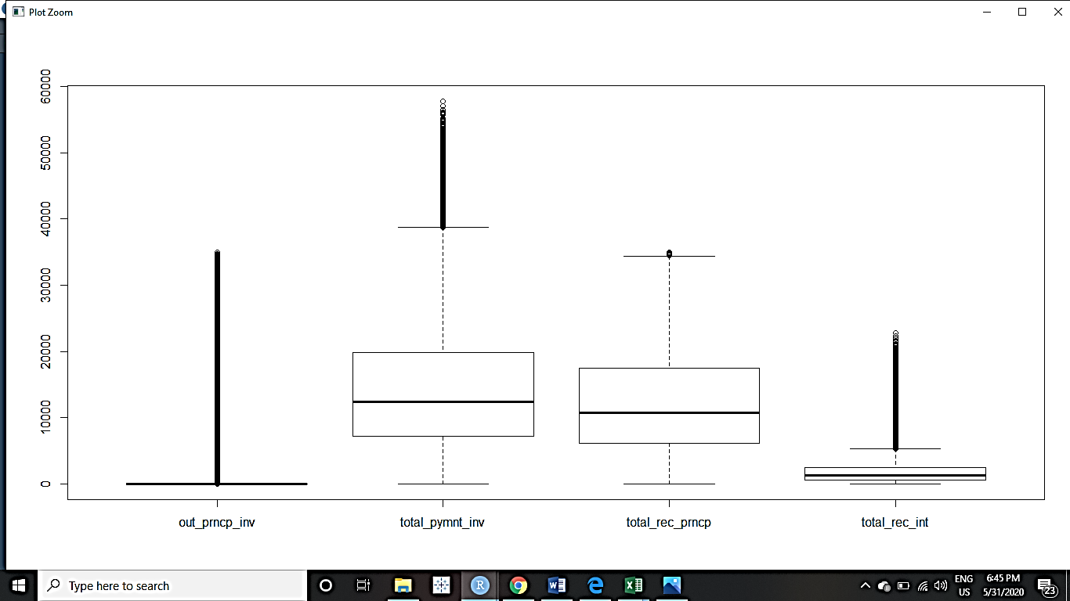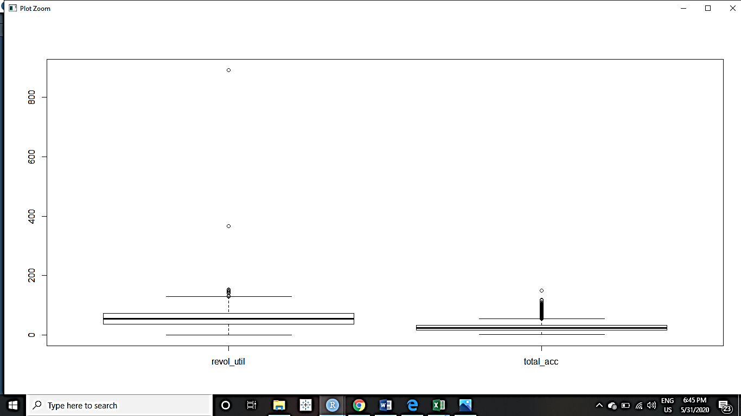

Therefore, we will treat the outlier values.

The method we are employing is capping the values by the use of interquartile range and changing the outlier values by imputing the values in range.

After the treatment of the outliers the new boxplot for the corrected ones comes out as given below.

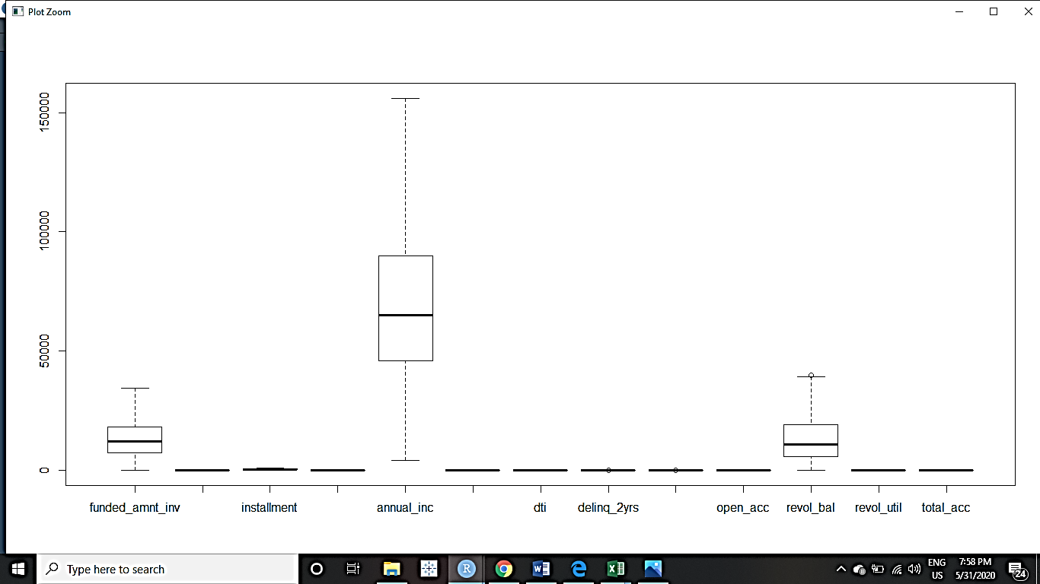

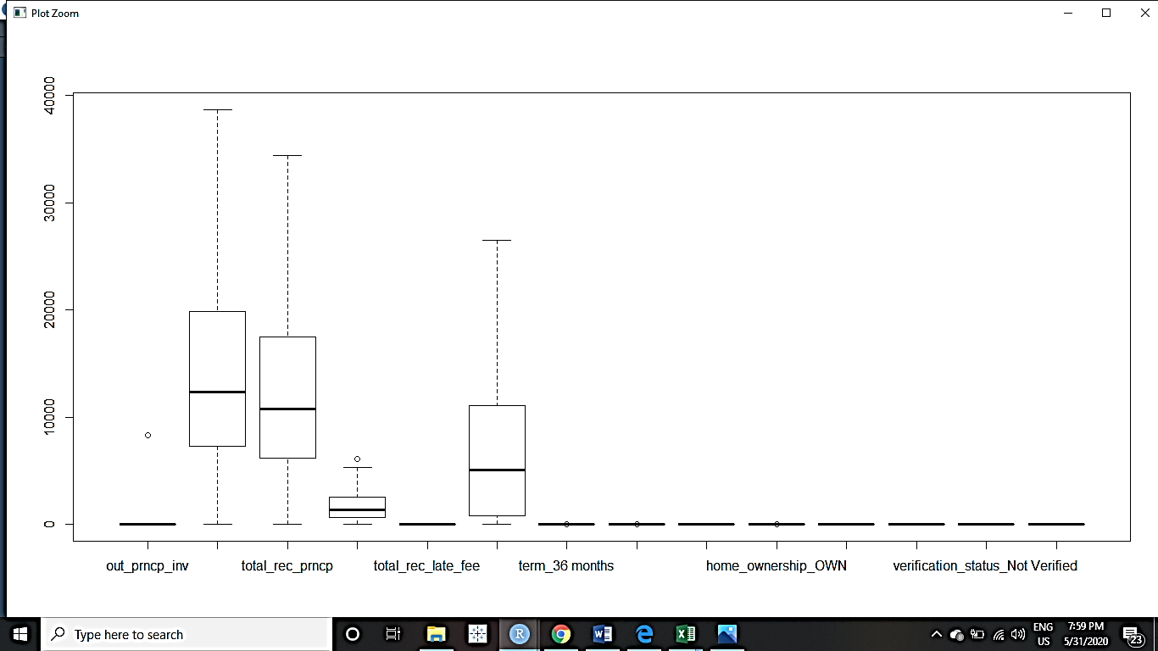

**SCALING**

We’ll perform scaling because the values of different variables are on very different scales. So we have to make them comparable to each other.

Feature **Scaling** is a technique to standardize the independent features present in the data in a fixed range. If feature **scaling** is not done, then a **machine learning algorithm** tends to weigh greater values, higher and consider smaller values as the lower values, regardless of the unit of the values.

scaledata=scale(finaldata[,-1])

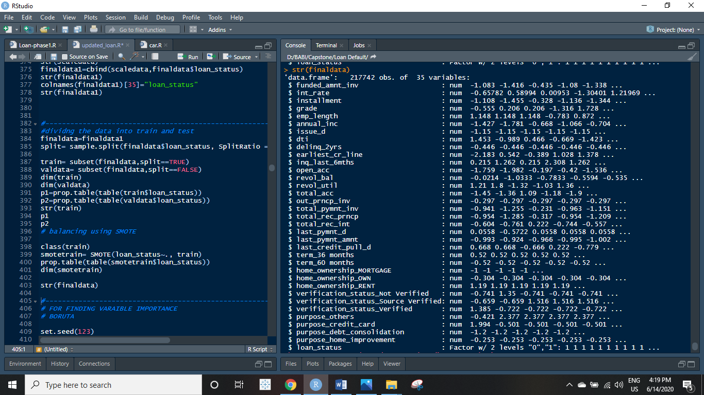

Therefore, now our whole dataset contains the independent variables of only numeric data type and the target variable which is a factor of 2 levels-0 & 1

**The dimensions of the final data:**

**Rows-> 217,742 Columns-> 35**

**5. ACTIONS/INSIGHTS FROM EXPLORATORY DATA ANALYSIS**

1. **The target variable in our dataset has two classes viz. “Fully Paid” and “Default”.** These classes are imbalanced. The proportion of Default is 8.4% of the total records. This is a scenario of imbalanced data. We have to balance this dataset so as to be able to improve on our sensitivity and predict the cases where the borrower will default, more efficiently.
2. There are 3 variables for which more than 50% records were missing. We removed those variable in prior. Rest of the variables had a low ratio of missing values around 4-5% which could be omitted too.
3. There are large number of outliers in each of the numerical variable. These outliers are capped so as to reduce the adverse effects that they could have on the machine learning model’s predictions.
4. The standard deviation and the variance within the data set is extremely high for many variables.
5. There were some variables which had super-collinearity. So those variables were removed to achieve a better functionality of our model.
6. We have manipulated the categorical type variables and now our dataset is purely numeric. This will help the machine learning algorithms to converge better.
7. Scaling has also been performed so that the values are well within comparable range.

**6.PREPARING THE DATA FOR MODEL BUILDING**

There are 2 crucial steps to be performed before actually fitting a model to the data. These are:

1. Splitting the dataset and

2. Balancing the training dataset

**Splitting the dataset**

We’ll take the entire dataset and split it into a ratio of 80:20. The 80% of the dataset will form our training set on which the models will be build. The remaining portion of 20% data is kept as a validation set or test set to gauge the model’s performance in terms of accuracy.

split= sample.split(finaldata$loan_status, SplitRatio = 0.80)

train= subset(finaldata,split==TRUE)

valdata= subset(finaldata,split==FALSE)

dim(train)

dim(valdata)

> dim(train)

[1] 174193 35

> dim(valdata)

[1] 43549 35

prop.table(table(train$loan_status))

prop.table(table(valdata$loan_status))

0 1

0.9187166 0.0812834

**Balancing the Training Set (USING SMOTE)**

SMOTE stands for Synthetic Minority Oversampling Technique. This is a statistical technique for increasing the number of cases in your dataset in a balanced way. The module works by generating new instances from existing minority cases that you supply as input.

smotetrain= SMOTE(loan_status~., train)

prop.table(table(smotetrain$loan_status))

0 1

0.5714286 0.4285714

Now, the dataset is balanced. The percentage of customers who defaulted rose from 6% to 42% of the entire records. Our models can be fitted now, on this data which has all the characteristics of both the defaulters and non-defaulters.

The dimension of the training set after balancing is: rows: 99,113 & columns= 35

**7.MODEL BUILDING AND INTERPRETATION**

The dataset is prepared completely and it is ready to undergo model building. We will create a plethora of models for our data and then compare those models using various metrics, to select the one which performs the best amongst all.

We will fit various predictive machine learning models to our data. The significance of fitting various models ensures that we are making an informed decision.

It is a good habit to take suggestions from all the models and then select the model which suggests the best.

We are shortlisting 4 models out of the many available. These models will be created independently of each other and then we will compare these models using various performance metrics to finally select THE ONE that suits our dataset the best.

So, we’ll be making are namely:

1. Logistic regression model
2. Support Vector machine
3. Bagging- Random Forest
4. Boosting- XGBOOST

1. **LOGISTIC REGRESSION MODEL**

Logistic Regression is a Machine Learning algorithm which is used for the classification problems, it is a predictive analysis algorithm and based on the concept of probability.

Bank defaults are well suited by this model since it is a classification problem. We get probabilities of default by each customer. The bank can adjust the threshold as per the business requirements.

log_model= glm(smotetrain$loan_status~., data=smotetrain,

family=binomial())

IMPORTANT VARIABLES IDENTIFIED :

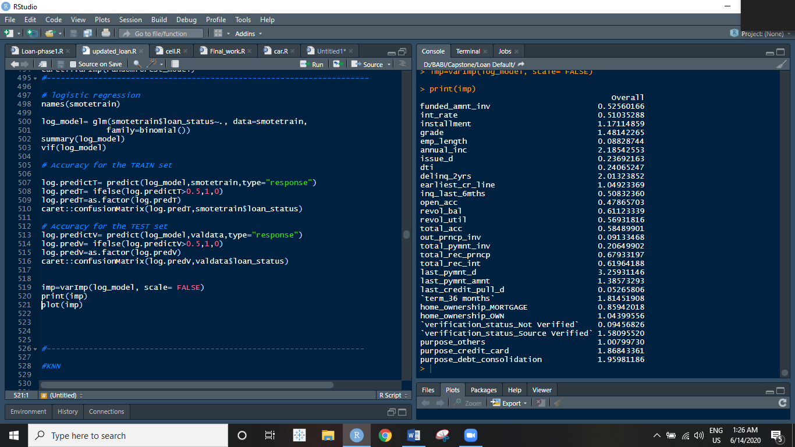

**CONFUSION MATRIX FOR TRAIN CONFUSION MATRIX FOR TEST**

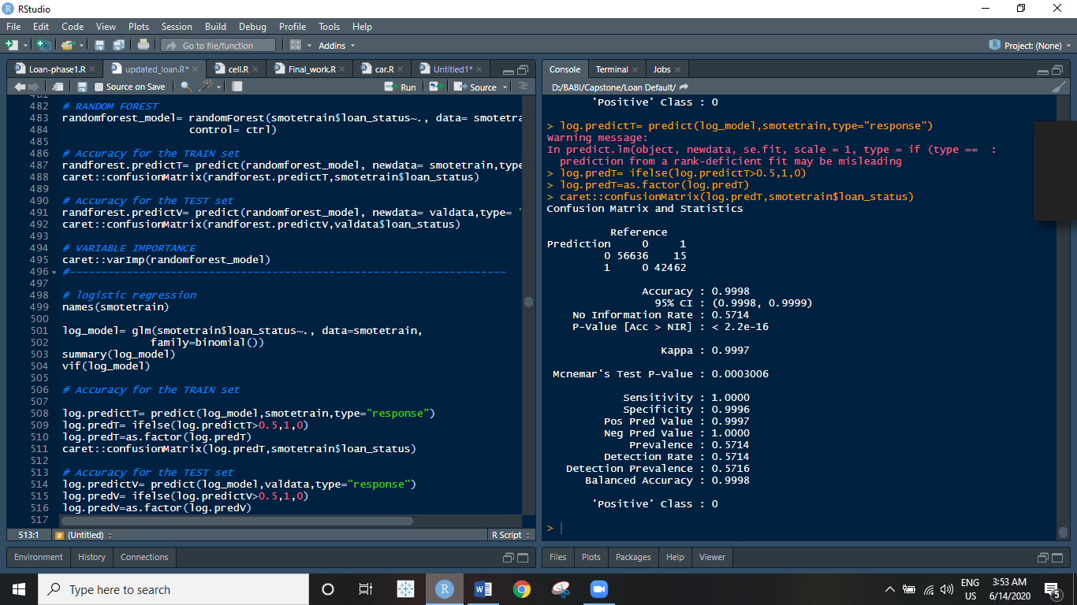 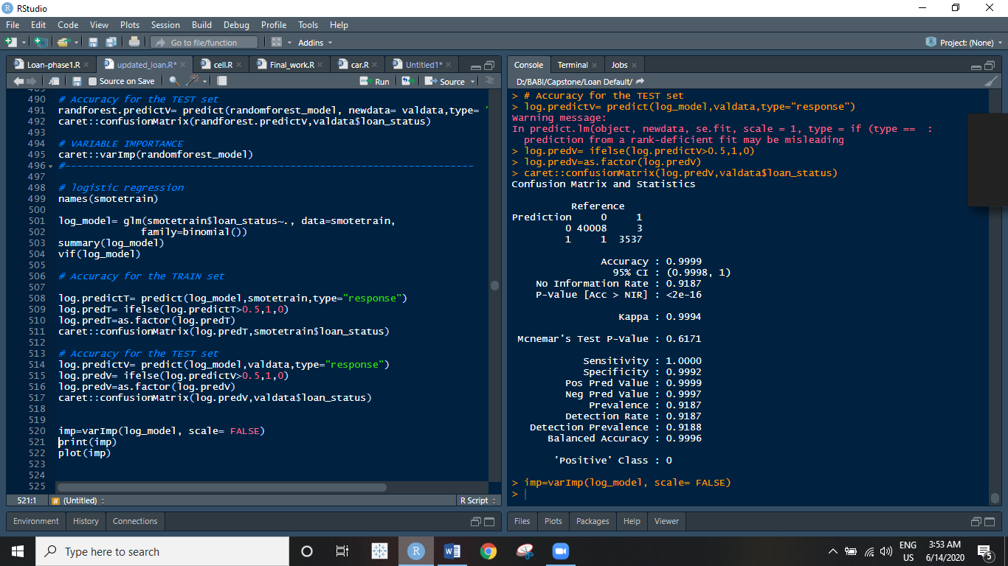

1. **SUPPORT VECTOR MACHINES**

**Support Vector Machine**” (**SVM**) is a supervised **machine learning** algorithm which can be used for both classification or regression challenges. However, it is mostly used in classification problems. And in our case of Deafulat classification, it serves just the right purpose.

svm_model = svm(formula = smotetrain$loan_status ~ .,

data = smotetrain,

type = 'C-classification',

kernel = 'linear')

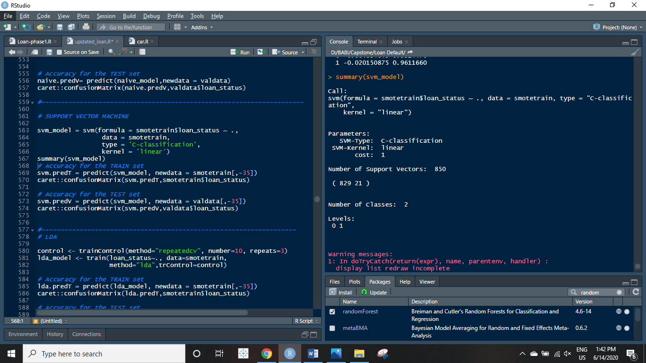

**CONFUSION MATRIX FOR TRAIN**  **CONFUSION MATRIX FOR TEST**

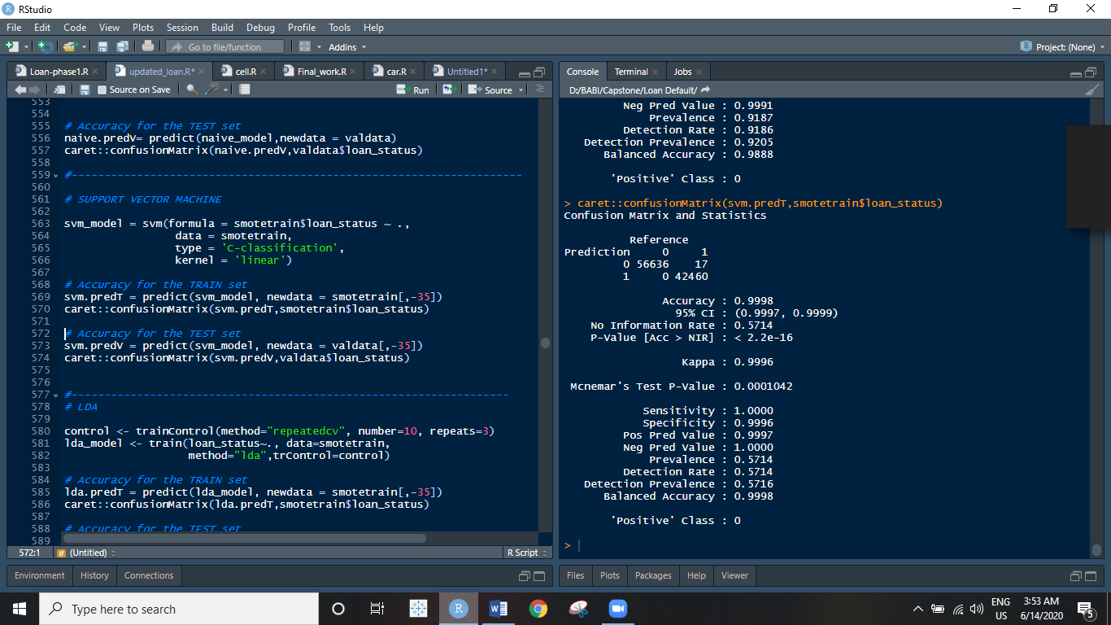 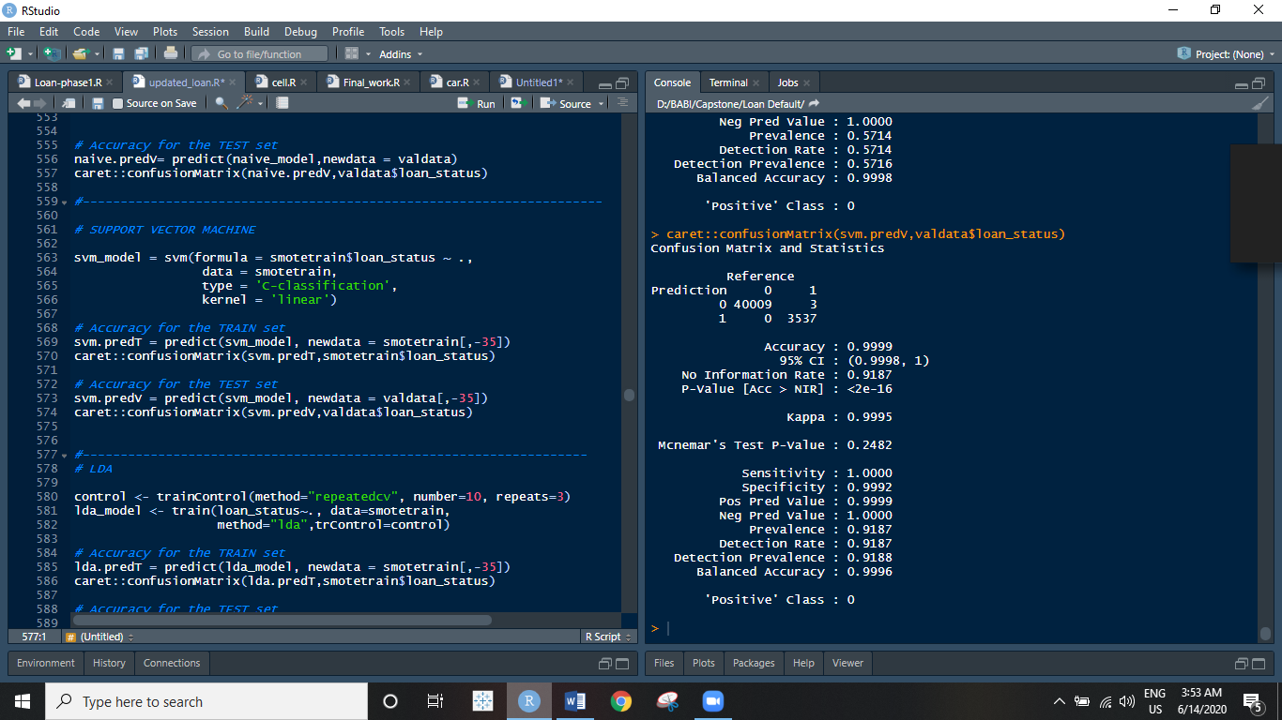

**Ensemble Model Creation (Using Hyper-Parameters For Tuning)**

**When we cannot trust the opinion of just one person, is it alright to trust your everything on one model?!** Ensemble learning follows the same concept. we create multiple models for the same predictive problem at hand for classification or regression. The various models built for the problem are then coupled together in different ways to give one final model. This final model is an Ensemble Machine Learning Model.

**This Ensemble model is called a Strong Learner**. And all the **standalone models which were used to make the final one, are referred to as weak learners**. An ideal model is one, that has low bias and low variance.

**We will fit 2 ensemble models to our data in hopes to achieving better accuracy.**

1. **Random Forest**
2. **XG-Boost**
3. **BAGGING USING RANDOM FOREST**

Random forests are a culmination of numerous CART trees. A cart is a single standalone model. A random forest is made up of a number of CART trees.

The output of these cart trees is aggregated and that aggregation is considered as the output/prediction of the random forest.

What goes in the creation of a Random Forest is the concept of bootstrap aggregation along with another technique of sample spacing, which means sampling over the features of the dataset.

Random forest is the addition of sample space technique with bagging for more robustness.

randomforest_model= randomForest(smotetrain$loan_status~., data= smotetrain,

control= ctrl)

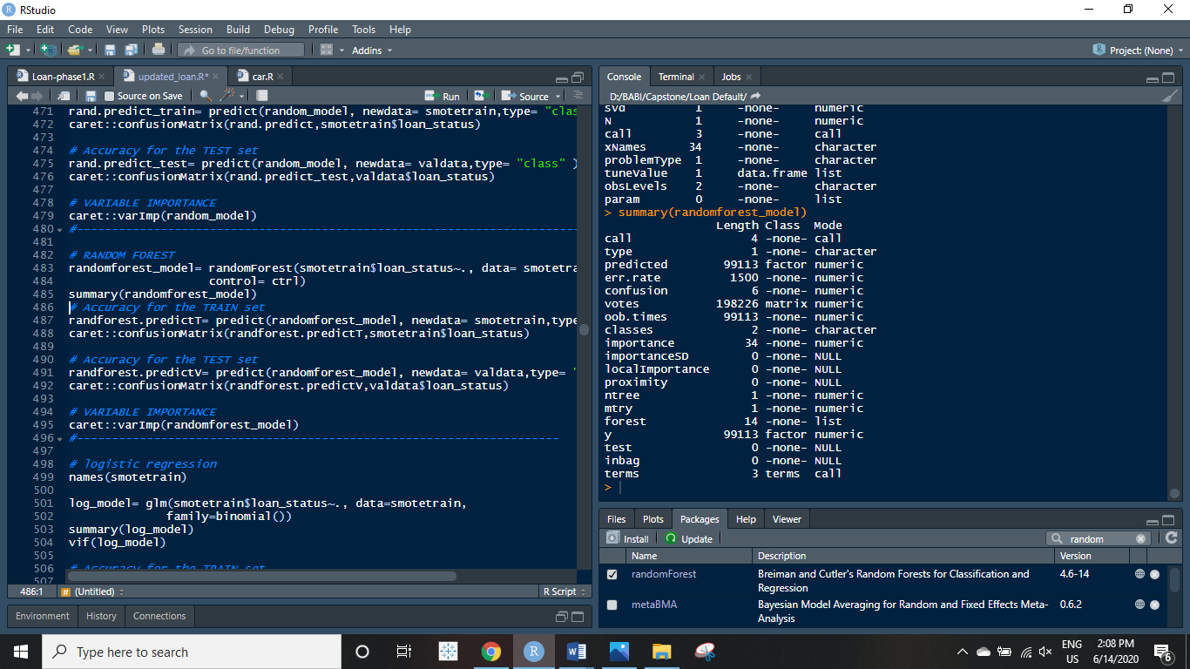

**CONFUSION MATRIX FOR TRAIN CONFUSION MATRIX FOR TEST**

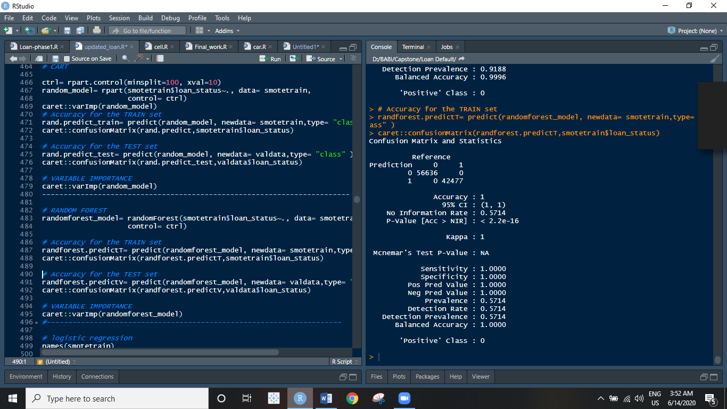 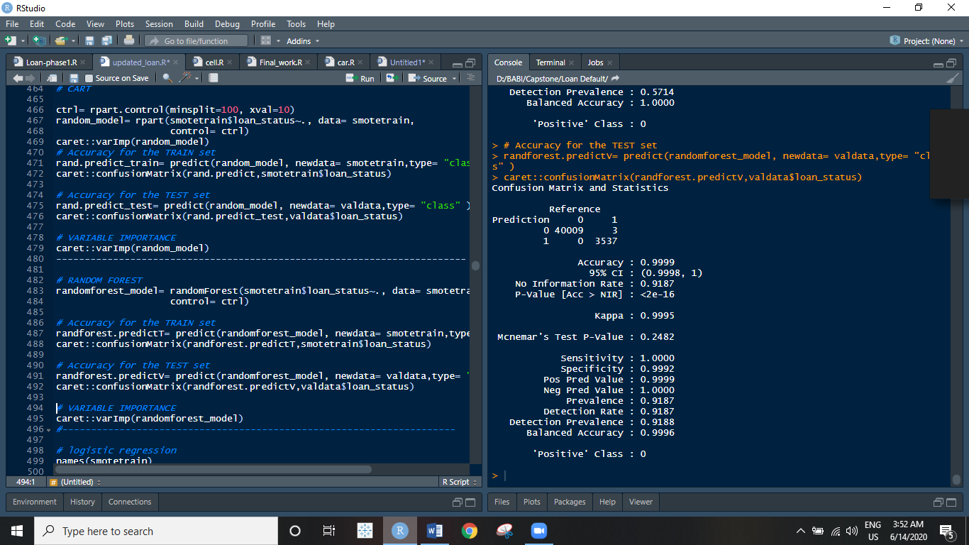

1. **BOOSTING USING XGBOOST MODEL**

In XG boosting, weak learners are created sequentially and added or aggregated in the end to create a strong leaner. It takes a cost function and applies it for each observation. This cost function will signify the error between the actual values and the predicted values.

In this classification problem of Loan Default, the cost function will tell us how good we predicted those which customer had defaulted. These errors are calculated after each model’s predictions and are called pseudo-residuals. XG boosting creates an ensemble model by employing the gradient boosting strategy in extreme form.

xgbmodel.final<-xgboost(data= features_train, label = label_train, eta=.3, max_depth=10,

min_child_weight=5, nrounds=100, nfold=50, objective= "binary:logistic",

verbose =0, early_stopping_rounds =100)

**CONFUSION MATRIX FOR TRAIN CONFUSION MATRIX FOR TEST**

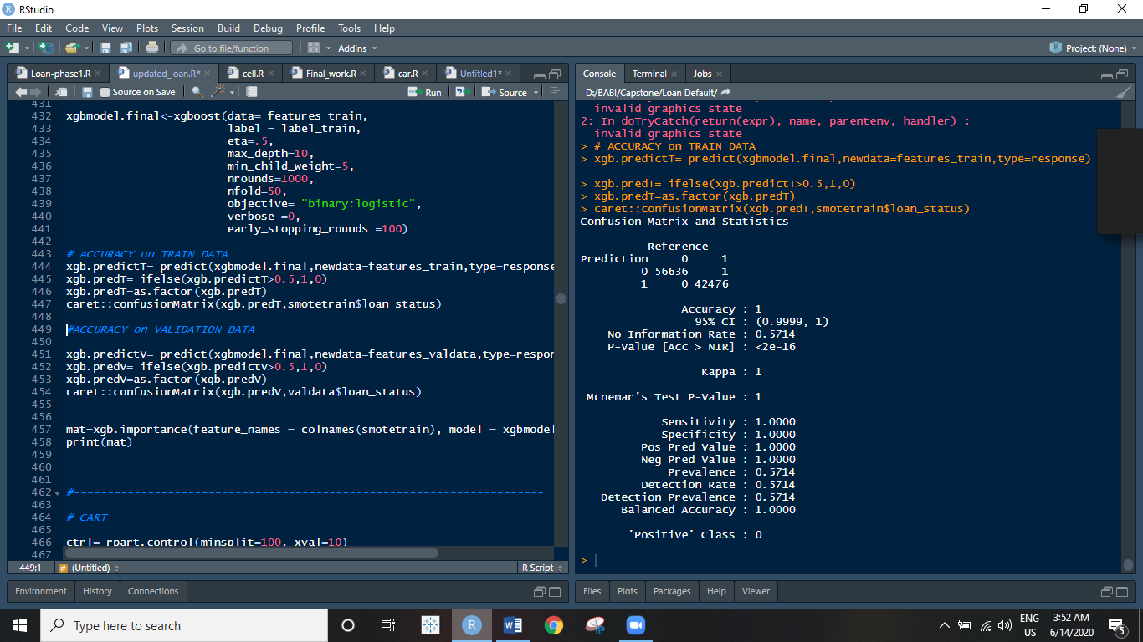 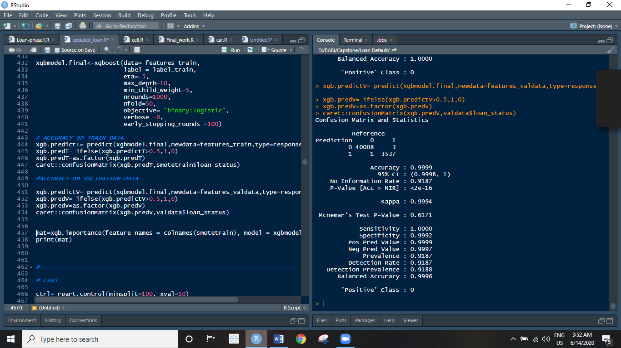

**8.COMPARING ALL THE PERFORMANCE METRICS OF THE MODELS**

**Firstly, Visualizing The ROC Curves**

* It shows the tradeoff between sensitivity (True Positive Rate or TPR) and specificity (1-FPR or False Positive Rate). Any increase in sensitivity will be accompanied by a decrease in specificity.
* The closer the curve follows the left-hand border and then the top border of the ROC space, the more accurate the model.

**\*A ROC curve of a perfect classifier**

A classifier with the perfect performance level shows a combination of two straight lines – from the origin (0.0, 0.0) to the top left corner (0.0, 1.0) and further to the top right corner (1.0, 1.0).

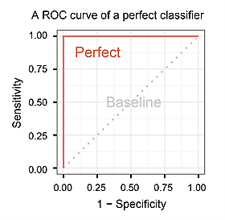

perf= performance(predicted,"tpr","fpr")

plot(perf,colorize=TRUE)

**XGBOOST**

**TRAIN TEST**

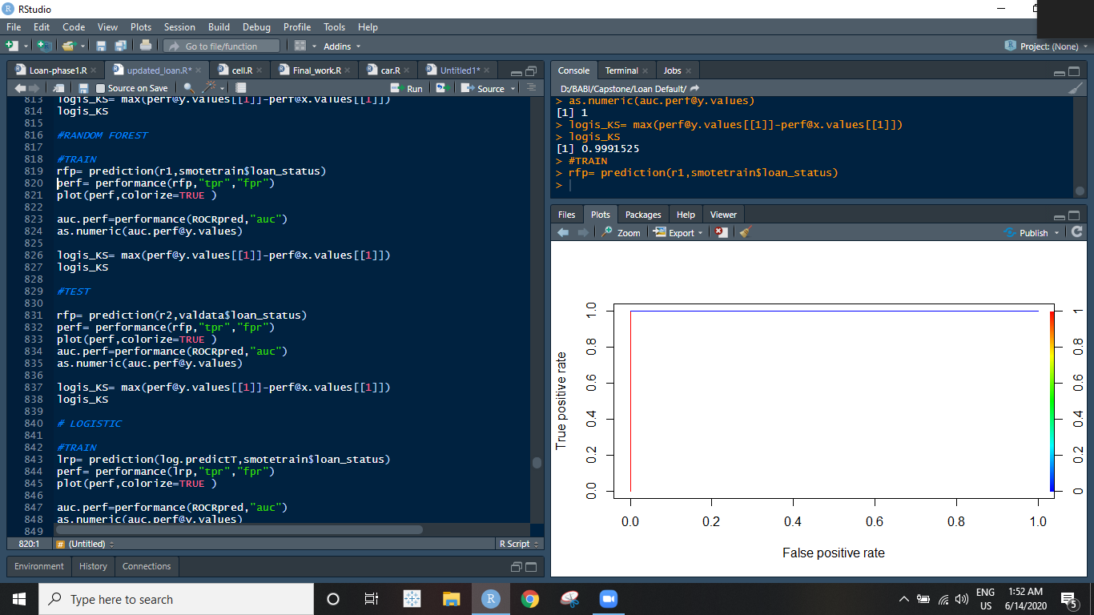 

**RANDOM FOREST**

**TRAIN TEST**

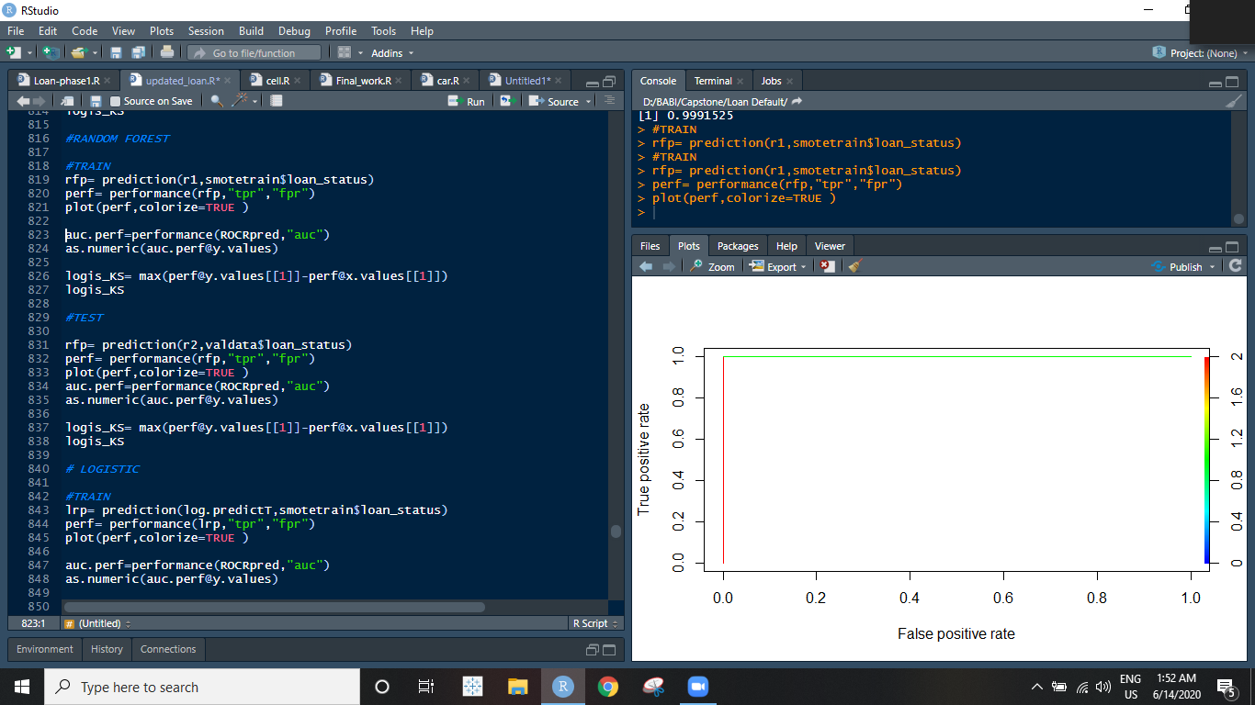 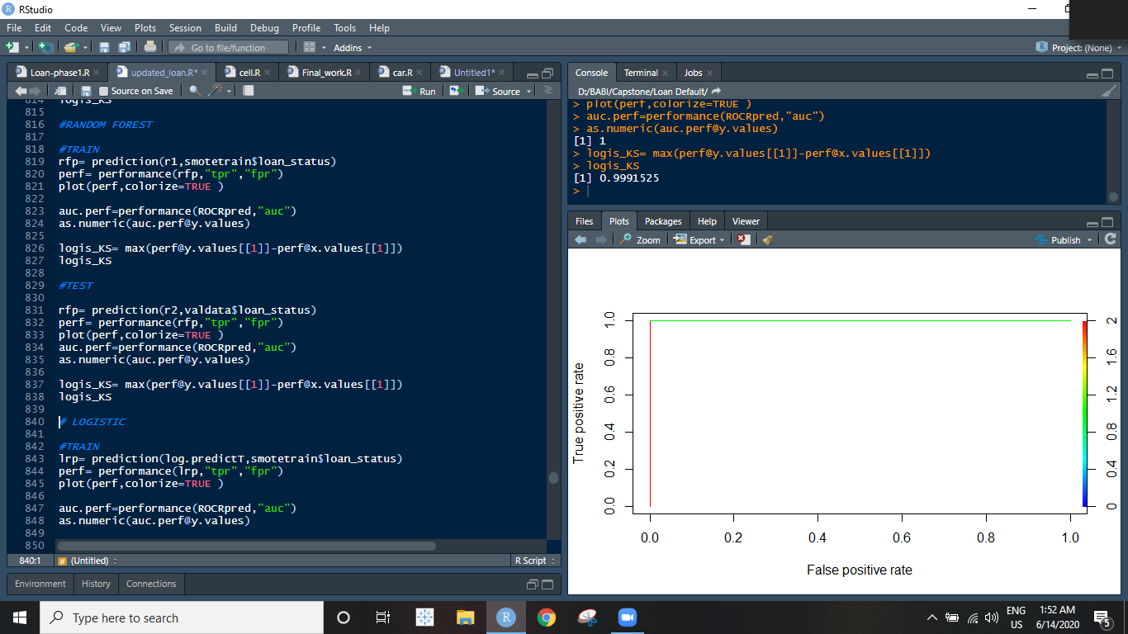

**LOGISTIC REGRESSION**

**TRAIN TEST**

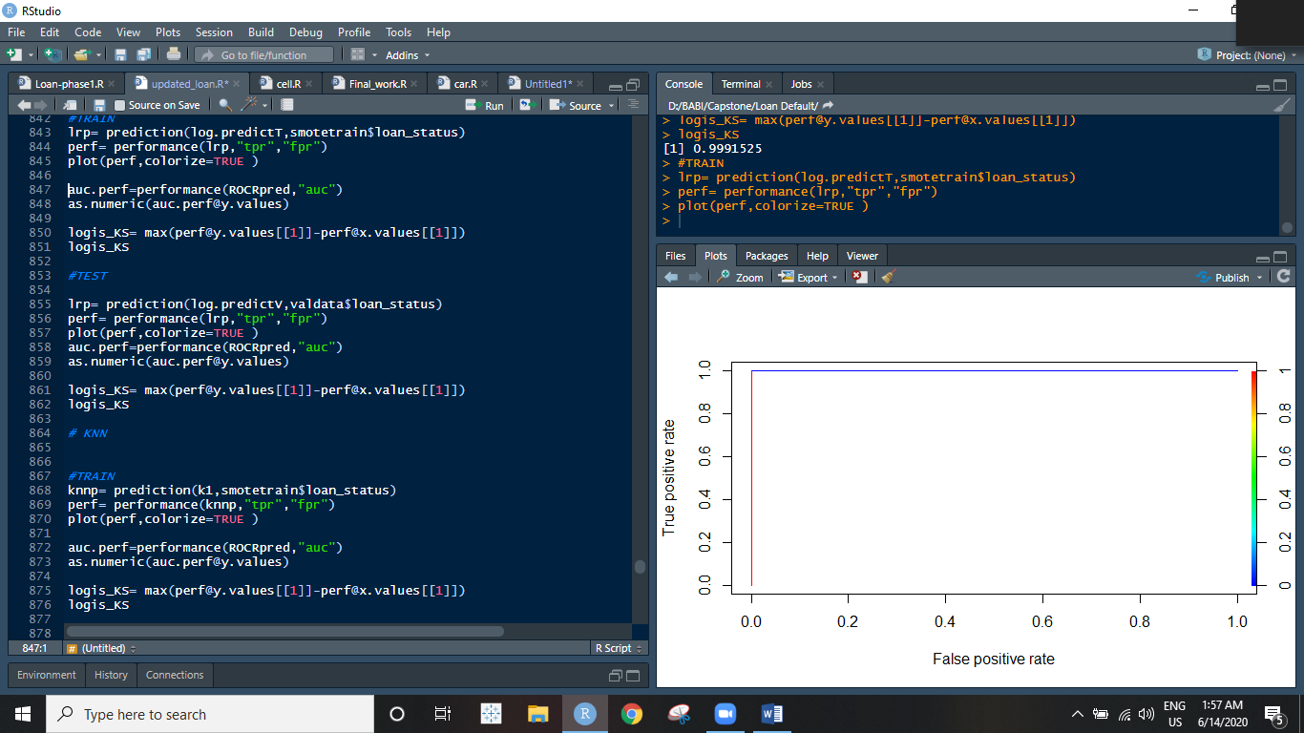 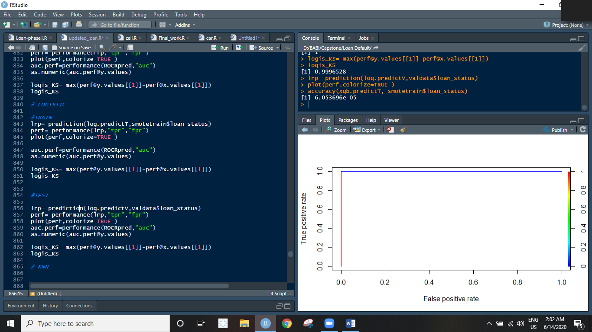

**SUPPORT VECTOR MACHINE**

**TRAIN TEST**

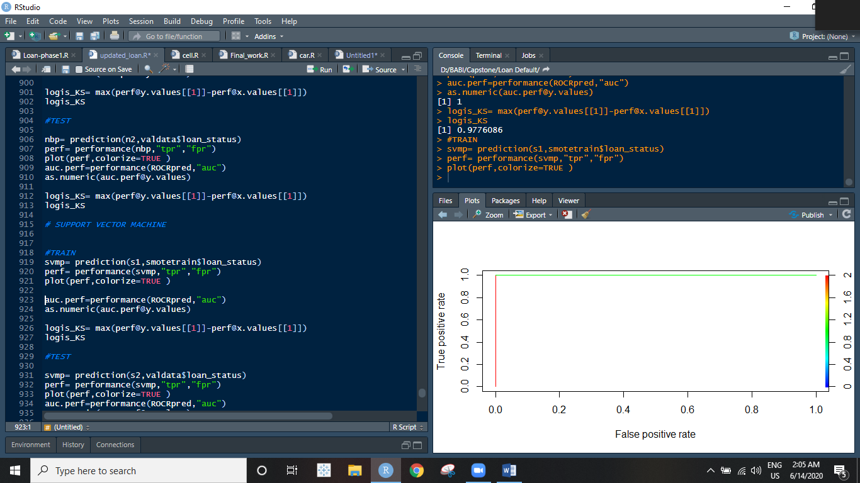 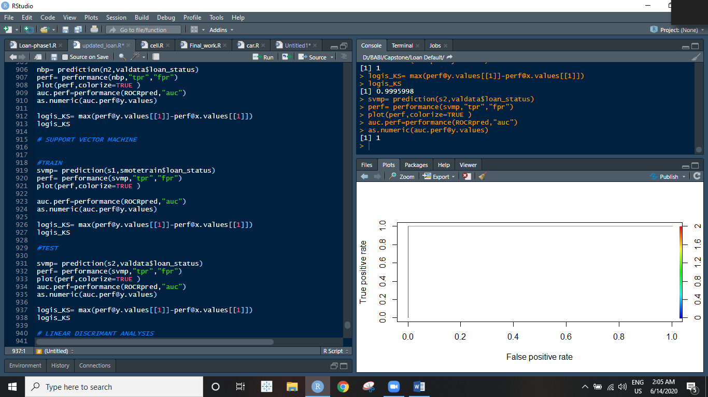

*For naked eye, there is no difference between the ROC’s plotted for these model’s train and test performances. So we’ll have to jump on to some other statistical measures to compare the performance and get a better clarity from different perspectives.

**COMPARING USING OTHER STATISTICALLY SIGNIFICANT MEASURES**

We shall discuss all the metrics on the basis of which we are going to compare which model to select as the final one.

* **Accuracy** is the fraction of predictions our model got right. **Accuracy** = Number of correct predictions Total number of predictions. **Accuracy is** the number of correctly predicted data points out of all the data points. More formally, it **is** defined as the number of true positives and true negatives divided by the number of true positives, true negatives, false positives, and false negatives.
* **Sensitivity** is a measure of the proportion of actual positive cases that got predicted as positive (or true positive). **Sensitivity** is also termed as Recall.

True Positive Rate = TP / (TP + FN)

* **Specificity** is defined as the proportion of actual negatives, which got predicted as the negative (or true negative). The sum of **specificity** and false positive rate would always be 1.

True negative Rate= TN / (TN + FP)

* **RMSE (Root Mean Squared Error)** is the standard deviation of the errors which occur when a prediction is made on a dataset. This is the same as MSE (Mean Squared Error) but the root of the value is considered while determining the accuracy of the model. In other words, it tells you how concentrated the data is around the line of best fit.

RMSE (predicted, actual)

* **R-Squared** is also known as the **coefficient of determination**. This metric gives an indication of how good a model fits a given dataset. It indicates how close the [regression line](https://www.studytonight.com/post/classification-problem-introduction-to-logistic-regression) (i.e., the predicted values plotted) is to the actual data values. The **R squared value lies between 0 and 1** where 0 indicates that this model doesn't fit the given data and 1 indicates that the model fits perfectly to the dataset provided.

R2(predicted, actual, form = "traditional")

* **MAE( Mean Absolute Error)**

We know that an error basically is the absolute difference between the actual or true values and the values that are predicted. Absolute difference means that if the result has a negative sign, it is ignored.

Hence, **MAE = True values – Predicted values**

MAE takes the **average** of this error from every sample in a dataset and gives the output.

MAE(predicted, actual)

* **K-S or Kolmogorov-Smirnov** chart measures performance of classification models. More accurately, **K-S** is a measure of the degree of separation between the positive and negative distributions.

The K-S range is between 0 and 1

The higher the K-S value, the better the model is at separating the positive from negative cases

max(perf@y.values[[1]]-perf@x.values[[1]])

* **GINI** index or **Gini** impurity measures the degree or probability of a particular variable being wrongly classified when it is randomly chosen. The Gini index is a well-established method to quantify the inequality among values of frequency distribution and can be used to measure the quality of a binary classifier. A Gini index of zero expresses perfect equality (or a totally useless classifier), while a Gini index of one expresses maximal inequality (or a perfect classifier).

ineq(predicted,type = "Gini")

**Let’s carefully scrutinize the below table. It has all the metrics for model performance of all the machine learning models we created on the train and the test.**

|  |  |  |  |  |  |  |  |  |  |
| --- | --- | --- | --- | --- | --- | --- | --- | --- | --- |
| MODEL |  | ACCURACY | SENSITIVITY | SPECIFICITY | RMSE | R-Squared | MAE | K-S | GINI |
|  | **Train** | 100% | 100% | 100% | 0.005121204 | 0.9998929 | 0.000166133 | 0.9991525 | 0.5714122 |
| XGBOOST | **Test** | 99.99% | 100% | 99.92% | 0.005121204 | 0.9998929 | 0.000166133 | 0.9991525 | 0.9184815 |
|  | **Train** | 100% | 100% | 100% | 0 | 1 | 0 | 1 | 0.5714286 |
| RANDOM FOREST | **Test** | 99.99% | 100% | 99.92% | 0.008299875 | 0.9990776 | 6.888792e-05 | 0.9991525 | 0.9187811 |
| LOGISTIC REGRESSION | **Train** | 99.98% | 100% | 99.96% | 0.01195995 | 0.9994159 | 0.0002874783 | 0.9996528 | 0.5714229 |
|  | **Test** | 99.99% | 100% | 99.92% | 0.009109948 | 0.9988887 | 0.000313297 | 0.9991525 | 0.9184661 |
| SVM | **Train** | 99.98% | 100% | 99.96% | 0.01309662 | 0.9992996 | 0.0001715214 | 0.9995998 | 0.5716001 |
|  | **Test** | 99.99 | 100% | 99.92 | 0.008299875 | 0.9990776 | 6.888792e-05 | 0.9991525 | 0.9187811 |

**9.INTERPRETATION OF BEST MODEL**

**There are 2 models which are performing the best for the given dataset:**

**1.XGBOOST 2. RANDOM FOREST**

**XG-Boost**

For the train set, it is predicting 42476 defaults out of 42477 correctly (just 1 default customer wasn’t spotted)



For the test set, it is predicting 3573 defaults out of 3576 correctly. And it wrongly identified 1 customer who didn’t really default as default.



**Random Forest**

For the train set, it is predicting 42477 defaults out of 42477 correctly (not even one 1 erroneous prediction)



For the test set, it is predicting 3573 defaults out of 3576 correctly. And it correctly identified all customers who didn’t default.



*Random forest is the clear winner here. But let’s see the remaining metrics too before making it our final model

**Comparing Random Forest and XG-Boost on the basis of other metrics**

|  |  |  |  |  |  |  |  |  |  |
| --- | --- | --- | --- | --- | --- | --- | --- | --- | --- |
| MODEL |  | ACCURACY | SENSITIVITY | SPECIFICITY | RMSE | R-Squared | MAE | K-S | GINI |
|  | **Train** | 100% | 100% | 100% | 0.005121204 | 0.9998929 | 0.000166133 | 0.9991525 | 0.5714122 |
| **XGBOOST** | **Test** | 99.99% | 100% | 99.92% | 0.005121204 | 0.9998929 | 0.000166133 | 0.9991525 | 0.9184815 |
|  | **Train** | 100% | 100% | 100% | 0 | 1 | 0 | 1 | 0.5714286 |
| **RANDOM FOREST** | **Test** | 99.99% | 100% | 99.92% | 0.008299875 | 0.9990776 | 6.888792e-05 | 0.9991525 | 0.9187811 |

**BEST MODEL – RANDOM FOREST**

So, on comparing each and every aspect, we come to the conclusion that for our Loan Default scenario, random forest is outperforming all the other models in terms of overall performance.

**In all aspects the RF model is either in competition with XGBoost or ahead in the game.**

Random forests are a reliable culmination of CART trees and the result they give is solid and trust worthy.

|  |  |  |  |  |  |  |  |  |  |
| --- | --- | --- | --- | --- | --- | --- | --- | --- | --- |
| MODEL |  | ACCURACY | SENSITIVITY | SPECIFICITY | RMSE | R-Squared | MAE | K-S | GINI |
|  | **Train** | 100% | 100% | 100% | 0 | 1 | 0 | 1 | 0.5714286 |
| RANDOM FOREST | **Test** | 99.99% | 100% | 99.92% | 0.008299875 | 0.9990776 | 6.888792e-05 | 0.9991525 | 0.9187811 |

The **RMSE** on the train was 0. This model is perfectly generalizing on the train dataset. The **R-Squared** value is 1 which corresponds to the idea that our model explains the dataset perfectly.

The false positives and the false negatives are both the least as given by random forest for the unseen data.

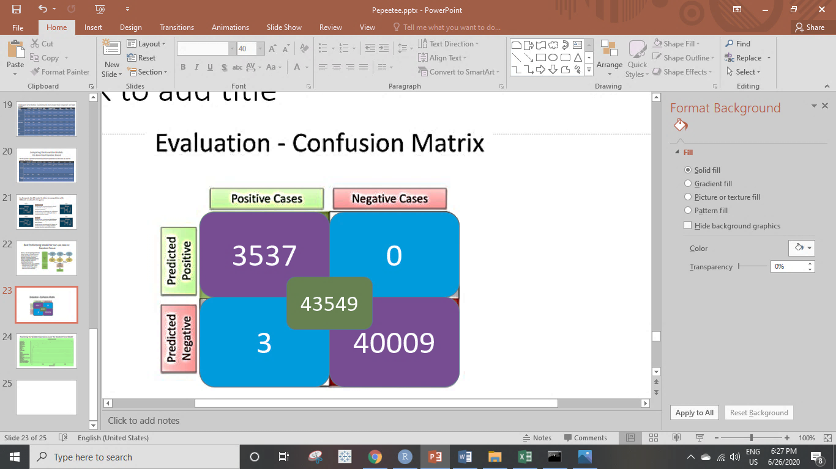

**Examining the Variable Importance as per the Random Forest Model**

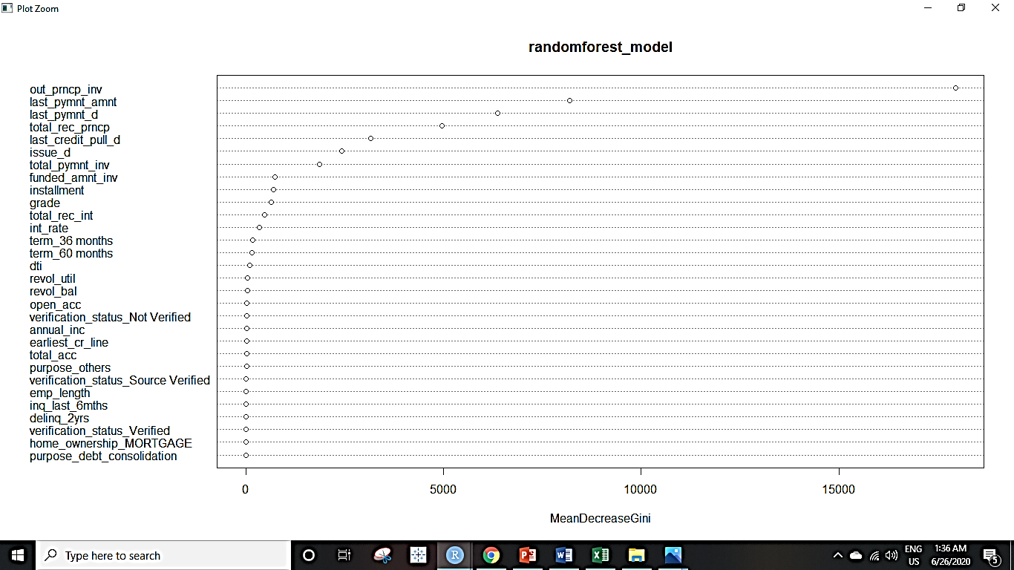

The most significant variables as identified by Random Forest are:

1. Outstanding Principal funded by Investor
2. Last payment Amount
3. Last Payment Date
4. Total Received Principal
5. Last credit pulled date
6. Issued date
7. Total payment received

**10.INSIGHTS AND RECOMMENDATIONS**

* Majority of the borrowers took loans for **debt consolidation** signifying that the population is under great debt.
* The Defaulters didn’t pay back 75.5% of the principal amount in totality.
* Due to Defaults, there was a loss of 7.2% on the Total amount funded for all the loans, which is a lot!
* The total profit that bank gained over the past 8 years is 15.5%.
* Borrowers from the states NE, MS & TN defaulted the most. Special scrutiny should be done of loan applications from these states.
* The Cream-Customers for the bank come majoritarily from CA, TX, FL & NY. These customers should be given some benefits in terms of interest rates so as to maintain their loyalty.
* The top 5 most important variables are: Outstanding Principal funded by Investor, Last payment Amount, Last Payment Date, Total Received Principal, Last credit pulled date. These attributes should be recorded with utmost care.
* The bank has invested in the verification of the loan applications, increasing from 0% in 2007 to 75% in 2015.
* In 2015, more than 25% of the customers Defaulted on the loan.
* The customers default doesn’t really depend upon their employment length.
* The no. of delinquencies has a directly proportional relation with the default.
* The bank should record more demographic information of the customer like age, marital status, children.
* There were variables with more than **50%** records as NAs and there are a large number of **outliers** in each of the numerical variable. The bank should invest in better data capturing and warehousing techniques so that we don’t lose important information.